**AMERICAN INTERNATIONAL UNIVERSITY BANGLADESH (AIUB)**

**FACULTY OF SCIENCE & TECHNOLOGY**



Course Title

**INTRODUCTION TO DATABASE (CSC2108)**

**Semester: 03  
Section: [W ]**

**TITLE**

**Hospital Management System**

**Supervised By**

Nyme Ahmed

**Submitted By: Group no: 03**

|  |  |
| --- | --- |
| **Name** | **ID** |
| MD.MINHAJUL SHARIAR ZAMAN ALIF | 23-54144-3 |
| TASFIA MAISHA | 23-54081-3 |
| ARGHYA DAS | 23-54149-3 |
| ANYKA AKTER AYNA | 23-54139-3 |

**TABLE OF CONTENTS**

|  |  |  |
| --- | --- | --- |
| **TOPICS** | | **Page no.** |
| **Title Page** | | **1** |
| **Table of Content** | | **2** |
| **1.** | **Introduction** | **3** |
| **2.** | **Case Study** | **4** |
| **3.** | **ER Diagram** | **5** |
| **4.** | **Normalization** | **6-13** |
| **5.** | **Finalization** | **14** |
| **6.** | **Table Creation** | **15-29** |
| **7.** | **Data Insertion** | **30-45** |
| **8.** | **Query Test** | **46-54** |
| **9.**  **10.** | **DB connection**  **Conclusion** | **55-66**  **67** |
|  |  |  |
|  |  |  |

# **Introduction**

The Hospital Management System is a centralized database solution designed to streamline healthcare operations by managing patient care, appointments, treatments, insurance, billing, and physician workflows. It tracks patients with personal details (name, address , date of birth , dynamically calculated age, multiple phone numbers) and their linked insurance policies , which include provider data and contact information. Patients schedule appointments with doctors , recorded with date and time, while medical histories log conditions, treatments, and associated physicians. Doctors maintain profiles with personal and employment details, and treatments track procedures, costs, and involved staff. The system automates billing , recording transaction methods and dates, and ensures data integrity through normalization (e.g., deriving age from DOB, decomposed addresses). By minimizing redundancy and enhancing scalability, this project empowers hospitals to improve operational efficiency, patient outcomes, and service transparency.

# **Case Study / Scenario**

One patient can do many appointment. Patient is identified by serial number(p_sn). The system also store name(p_name) , address(p_address), dob(p_dob), age(p_age), phone number(p_phone). Address(p_address) is composed of city(p_city), district(p_district). Age(p_age) is dependent on dob(p_dob). Phone number(p_phone) is a multiple variable.  Appointment is identified appointment id(a_id). The system also store doctor name (d_name),date(a_date) and time(a_time). One patient has one insurance. Insurance is identified by insurance id(i_id) . The system also store provider name(i_store_provider), address(i_address) and phone number(i_phone). Phone number(i_phone) has multiple variables. On the other hand address is composed of city(i_city), district(i_district). Many patients has many medical history. Medical history is identified by history id(mh_history_id). The systems also store patient id(p_id) , medical condition(mh_mc),date(mh_date), treatment history(mh_treatment_history). Treatment history is composed of doctor treatment cost(t_cost) , doctor name(d_name). One Patient can hire many doctor . Doctor is identified by doctor id(d_id). The system also store phone number(d_phone), hiredate(d_hiredate) , bonus(d_bonus) , address(d_address). Address(d_address) is composed of city(d_city), district(d_district).Phone number(d_phone) has multiple variables. One patient can do many treatment. Treatment is identified by treatment id(t_id). The system also store treatment cost(t_cost) and treatment type(t_type) . Many treatment are done by one doctor.  Many patients can do many bill . Bill is identified by transaction id(bill_id) . The system also store  bill date(bill_date), bill time(bill_time), transaction method(bill_transaction) , bill name(bill_name). Bill transaction is composed of first transaction(f_transaction) and last transaction(l_transaction)

**ER Diagram**

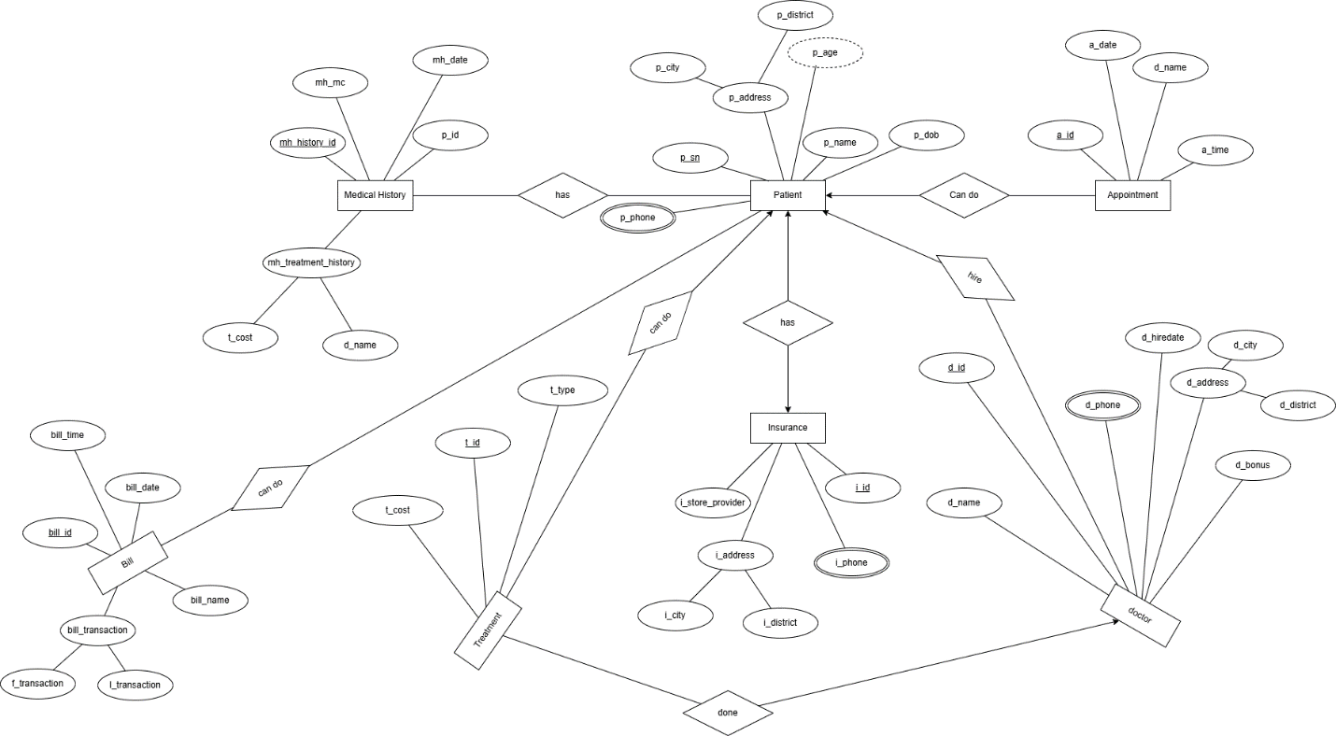

# **Normalization**

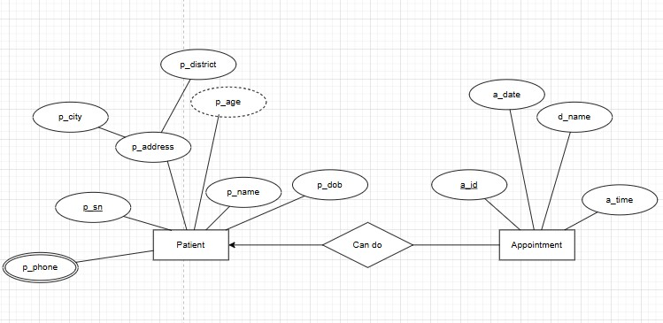

**Relation:** One to Many

**UNF:** p_phone,p_sn, p_city,p_district,p_name,p_dob,p_age,a_id, a_date, d_name,a_time

**1NF:**  Multivalue attribute: p_phone

p_sn, p_city,p_district,p_name,p_dob,p_age,a_id, a_date, d_name,a_time

**2NF:**  1) p_sn.p_phone

          2)p_sn,p_district,p_city,p_dob,p_age,p_name

          3)a_id, a_date,d_name,a_time,p_sn

**3NF:** 1) p_sn, p_phone

         2) p_sn, p_city,p_district

         3) p_sn, p_dob,p_age,p_name

         4)a_id, a_date,d_name,a_time,p_sn

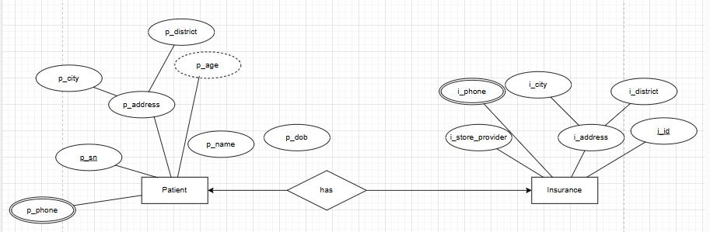

**Relation:** One to One

**UNF:** p_phone,i_phone,p_sn, p_city,p_district,p_name,p_dob,p_age,i_id, i_store_provider,i_city,i_district,i_phone

**1NF:**  Multivalue attribute: p_phone,i_phone

p_sn, p_city,p_district,p_name,p_dob,p_age,i_id, i_store_provider,i_city,i_district,i_phone

**2NF:**  1) p_sn.p_phone

          2)p_sn,p_district,p_city,p_dob,p_age,p_name

          3)i_id,  i_phone

          4)i_id, i_store_provider,i_city,i_district

**3NF:** 1) p_sn, p_phone

         2) p_sn, p_city,p_district

         3) p_sn, p_dob,p_age,p_name

         4)i_id,i_city,i_district

         5)i_id, i_store_provider

         6)i_id,i_phone

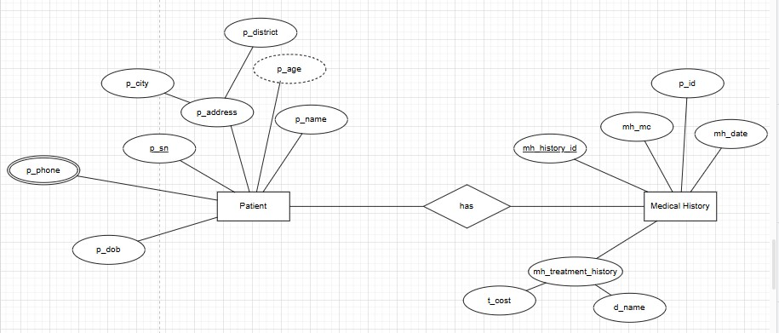

***Patient ->Medical History***

**Relation:** many to many

**UNF:** p_phone,p_sn, p_city,p_district,p_name,p_dob,p_age,mh_history_id, mh_mc, mh_date, p_id, t_cost,d_name

**1NF:**  Multivalue attribute: p_phone

p_sn, p_city,p_district,p_name,p_dob,p_age,mh_history_id, mh_mc, mh_date, p_id, t_cost,d_name

**2NF:**  1) p_sn.p_phone

          2)p_sn,p_district,p_city,p_dob,p_age,p_name

          3)mh_history_id,  mh_mc,mh_date,p_id,t_cost,d_name,p_sn

**3NF:** 1) p_sn, p_phone

         2) p_sn, p_city,p_district

         3) p_sn, p_dob,p_age,p_name

         4)mh_history_id,t_cost,d_name

         5)mh_history_id, mh_mc,mh_date,p_id,p_sn

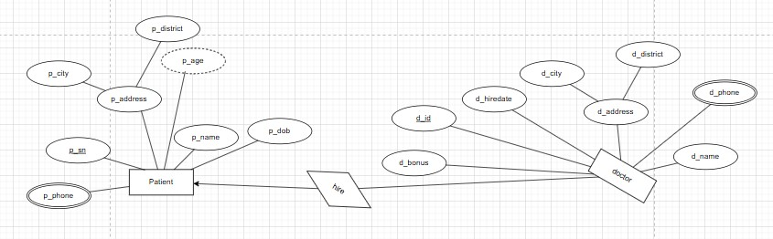

**Relation:** One to many

**UNF:**  p_phone,d_phone,p_sn, p_city,p_district,p_name,p_dob,p_age, d_id, d_name,d_bonus, d_hiredate,d_city,d_district

**1NF:**  Multivalue attribute: p_phone,d_phone

p_sn, p_city,p_district,p_name,p_dob,p_age, d_id, d_name,d_bonus, d_hiredate,d_city,d_district

**2NF:**  1) p_sn.p_phone

          2)p_sn,p_district,p_city,p_dob,p_age,p_name

          3)d_id, d_phone

          3)d_id, d_name,d_hiredate,d_city,d_d_district,d_bonus,p_sn

**3NF:** 1) p_sn, p_phone

         2) p_sn, p_city,p_district

         3) p_sn, p_dob,p_age,p_name

         4)d_id, d_phone

         5)d_id, d_city,d_district

         6)d_id, d_name,d_bonus,d_hiredate,p_sn

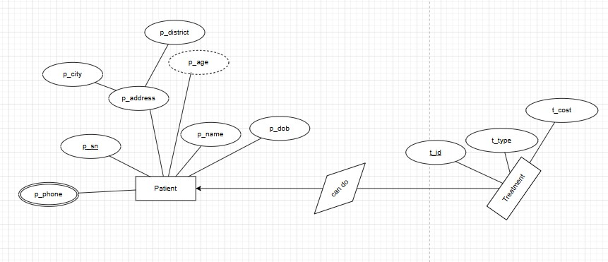

**Relation:** One to many

**UNF:** p_phone,p_sn, p_city,p_district,p_name,p_dob,p_age, t_id, t_cost,t_type

**1NF:**  Multivalue attribute: p_phone

p_sn, p_city,p_district,p_name,p_dob,p_age, t_id, t_cost,t_type

**2NF:**  1) p_sn.p_phone

          2)p_sn,p_district,p_city,p_dob,p_age,p_name

          3)t_id, t_cost, t_type,p_sn

**3NF:** 1) p_sn, p_phone

         2) p_sn, p_city,p_district

         3) p_sn, p_dob,p_age,p_name

         4)t_id, t_cost,t_type,p_sn

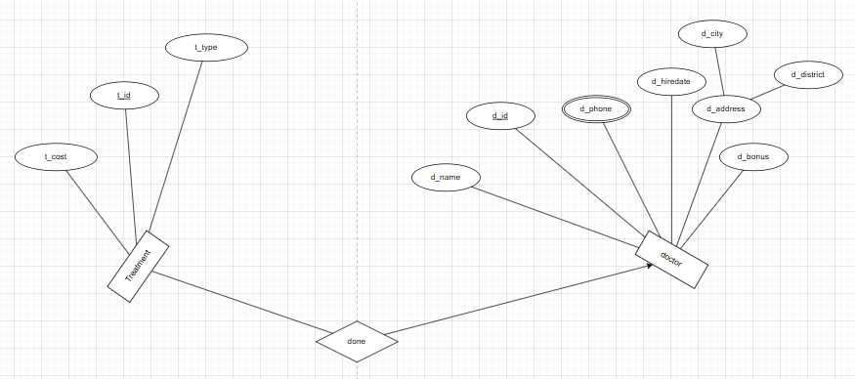

**Relation:** many to one

**UNF:** d_phone, t_id, t_cost,t_type, d_id, d_name,d_bonus, d_hiredate,d_city,d_district

**1NF:**  Multivalue attribute: d_phone

 t_id, t_cost,t_type, d_id, d_name,d_bonus, d_hiredate,d_city,d_district

**2NF:**  1) t_id,t_cost,t_type,d_id

          2)d_id, d_phone

          3)d_id, d_name,d_bonus,d_hiredate,d_city,d_district

**3NF:** 1)t_id,t_cost,t_type,d_id

         4)d_id, d_phone

         5)d_id, d_city,d_district

         6)d_id, d_name,d_bonus,d_hiredate

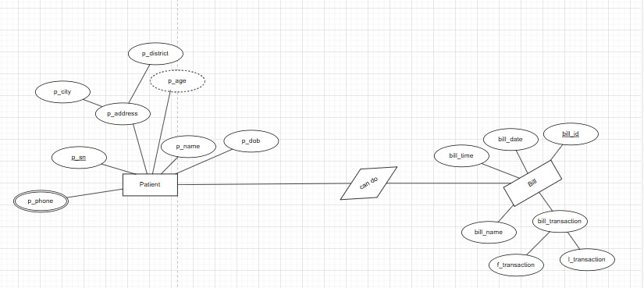

**Relation:** many to many

**UNF:** p_phone, p_sn, p_city,p_district,p_name,p_dob,p_age, bill_id, bill_time,bill_date,f_transaction,l_transaction,bill_name

**1NF:**  Multivalue attribute: p_phone

p_sn, p_city,p_district,p_name,p_dob,p_age, bill_id, bill_time,bill_date,f_transaction,l_transaction,bill_name

**2NF:**  1) p_sn.p_phone

          2)p_sn,p_district,p_city,p_dob,p_age,p_name

          3)bill_id, bill_time,bill_date,f_transaction,l_transaction,bill_name,p_sn

**3NF:** 1) p_sn, p_phone

         2) p_sn, p_city,p_district

         3) bill_id,f_transaction,l_transaction

         4)bill_id,bill_time,bill_date,bill_name, p_sn

# **Finalization**

## Eliminate the duplicate tables if found any in normalization after 3NF. Show the final tables of the system with their name.

**TOTAL RELATIONS**

1. p_sn, p_phone
2. p_sn, p_city,p_district
3. p_sn, p_dob,p_age,p_name
4. a_id, a_date,d_name,a_time,p_sn
5. ~~p_sn, p_phone~~
6. ~~p_sn, p_city,p_district~~
7. ~~p_sn, p_dob,p_age,p_name~~
8. i_id,i_city,i_district
9. i_id, i_store_provider
10. i_id,i_phone
11. ~~p_sn, p_phone~~
12. ~~p_sn, p_city,p_district~~
13. ~~p_sn, p_dob,p_age,p_name~~
14. mh_history_id,t_cost,d_name
15. mh_history_id, mh_mc,mh_date,p_id,p_sn
16. ~~p_sn, p_phone~~
17. ~~p_sn, p_city,p_district~~
18. ~~p_sn, p_dob,p_age,p_name~~
19. d_id, d_phone
20. d_id, d_city,d_district
21. d_id, d_name,d_bonus,d_hiredate,p_sn
22. ~~p_sn, p_phone~~
23. ~~p_sn, p_city,p_district~~
24. ~~p_sn, p_dob,p_age,p_name~~
25. ~~t_id, t_cost,t_type~~
26. t_id, t_cost,t_type,p_sn
27. t_id,t_cost,t_type,d_id
28. ~~d_id, d_phone~~
29. ~~d_id, d_city,d_district~~
30. ~~d_id, d_name,d_bonus,d_hiredate~~
31. ~~p_sn, p_phone~~
32. ~~p_sn, p_city,p_district~~
33. bill_id,f_transaction,l_transaction
34. bill_id,bill_time,bill_date,bill_name, p_sn

**TOTAL RELATIONS**

1. p_sn, p_phone
2. p_sn, p_city,p_district
3. p_sn, p_dob,p_age,p_name
4. a_id, a_date,d_name,a_time,p_sn
5. i_id,i_city,i_district
6. i_id, i_store_provider
7. i_id,i_phone
8. mh_history_id,t_cost,d_name
9. mh_history_id, mh_mc,mh_date,p_id,p_sn
10. d_id, d_phone
11. d_id, d_city,d_district
12. d_id, d_name,d_bonus,d_hiredate,p_sn
13. t_id, t_cost,t_type,p_sn
14. t_id,t_cost,t_type,d_id
15. bill_id,f_transaction,l_transaction
16. bill_id,bill_time,bill_date,bill_name, p_sn

# **Table Creation (DDL Operations)**

|  |  |  |
| --- | --- | --- |
| StudentID1: 23-54144-3 Name:MD.MINHAJUL SHARIAR ZAMAN ALIF | StudentID3: 23-54149-3 Name: ARGHYA DAS | |
| StudentID2: 23-54081-3 Name:TASFIA MAISHA | StudentID4: 23-54139-3 Name: ANYKA AKTER AYNA | |
| **CO4**: Creating DML, DDL using Oracle and connection with ODBC/JDBC for existing JAVA application | | |
| **PO-e-2:** Use modern engineering and IT tools for prediction and modeling of complex computer science and engineering problem | | Marks |

## Provide the screenshots of your commands for created tables in oracle.   
## Provide the description which shows the structure of the table.

**TABLE-1**

create table table1(p_sn number(10,0) primary key, p_phone number(11))

desc table1

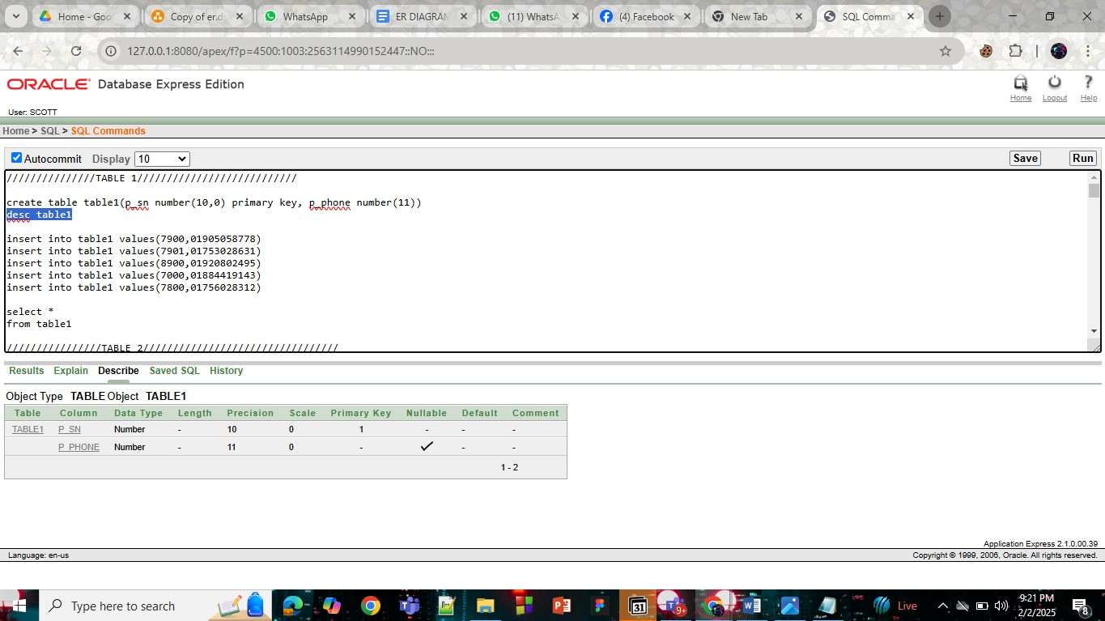

**TABLE-2**

create table table2(p_sn number(10,0) primary key, p_city varchar2(20),p_district varchar2(20))

desc table2

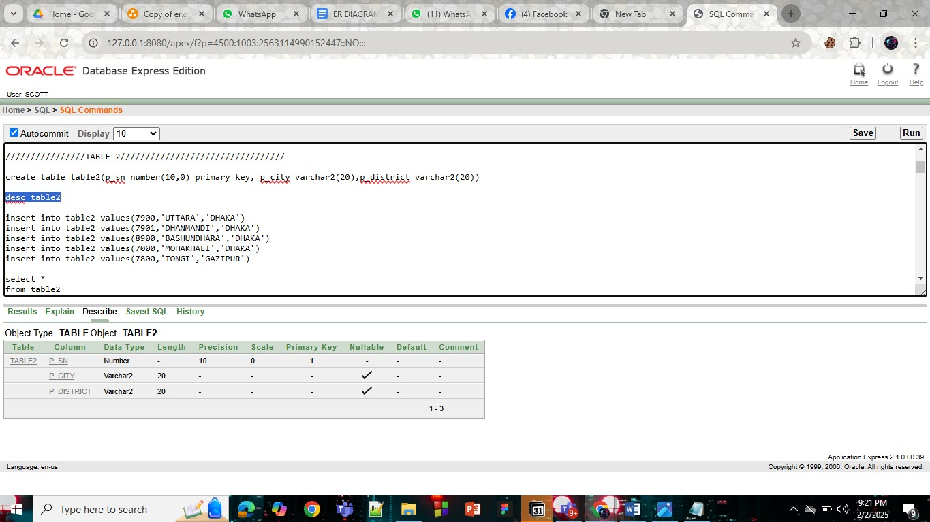

**TABLE-3**

create table table3(p_sn number(10,0) primary key,p_name varchar2(100), p_dob date,p_age int)

desc table3

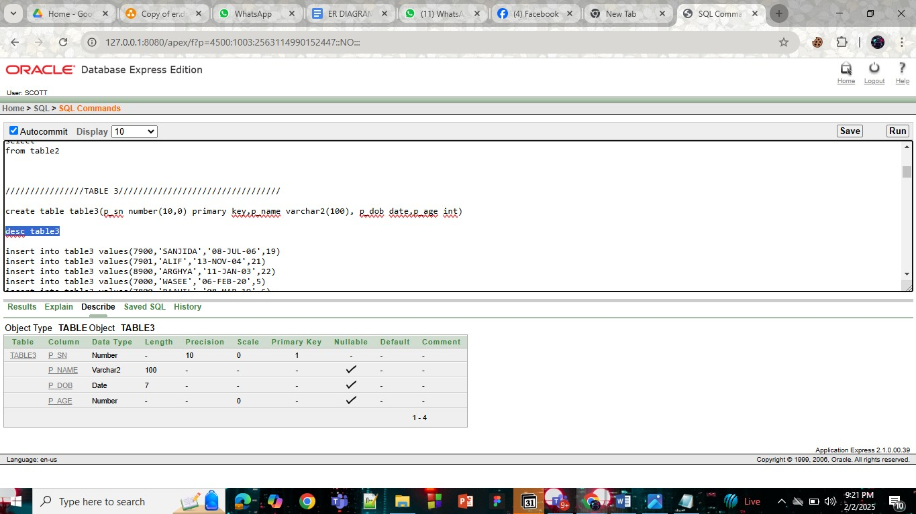

**TABLE-4**

create table table4(a_id int primary key,a_date date, d_name varchar2(100),a_time varchar2(7), p_sn number(10,0), foreign key(p_sn) references table1(p_sn))

desc table4

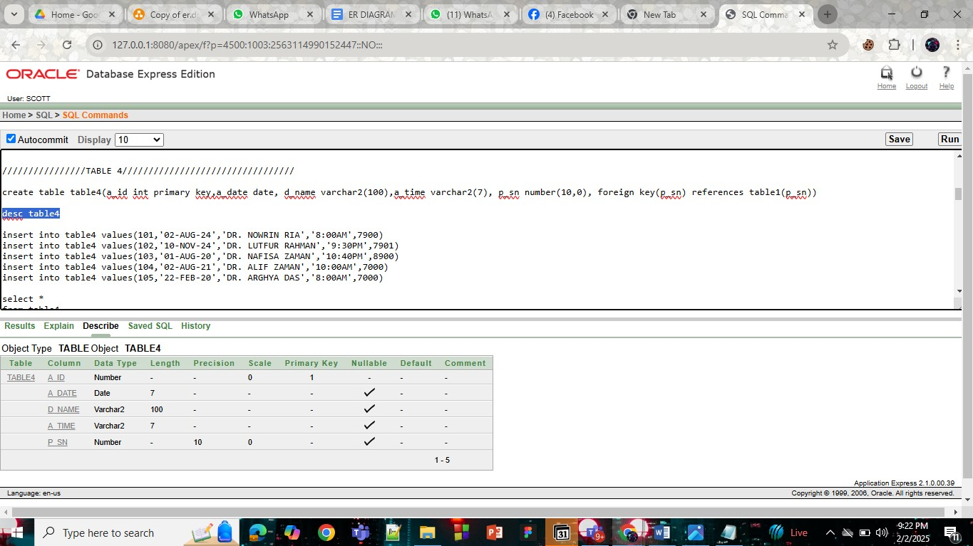

**TABLE-5**

CREATE TABLE table5 (i_id INT PRIMARY KEY,i_city VARCHAR(100),i_district VARCHAR(100))

desc table5

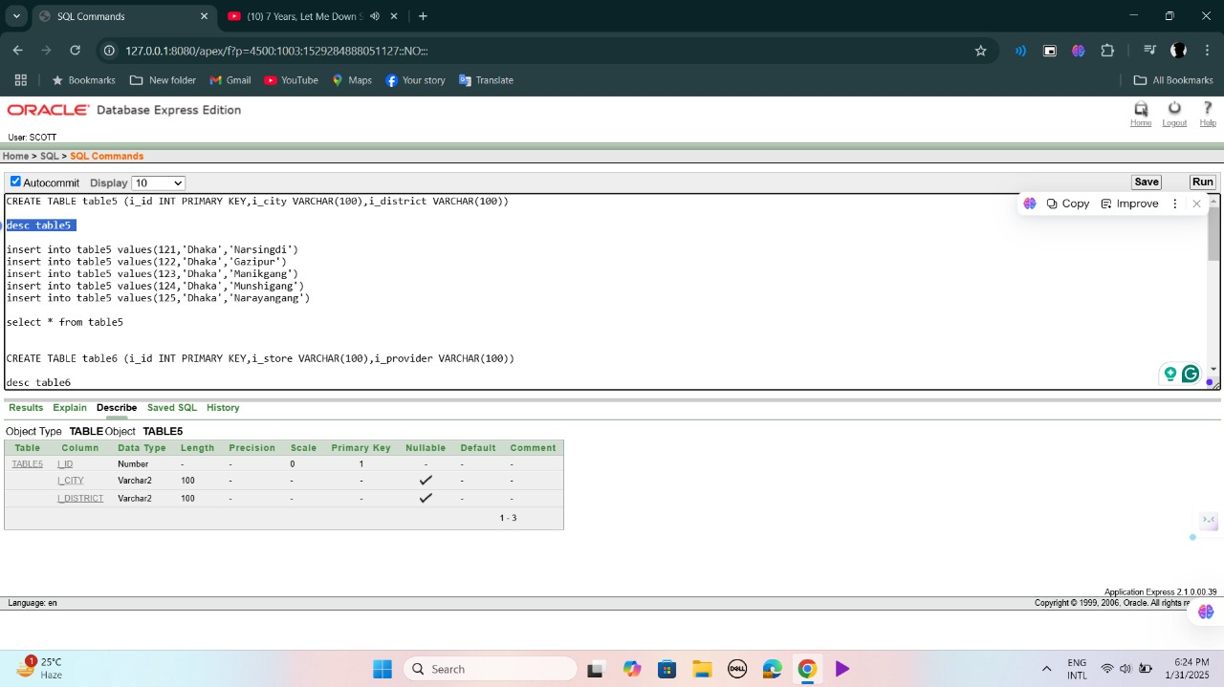

**TABLE-6**

CREATE TABLE table6 (i_id INT PRIMARY KEY,i_store VARCHAR(100),i_provider VARCHAR(100))

desc table6

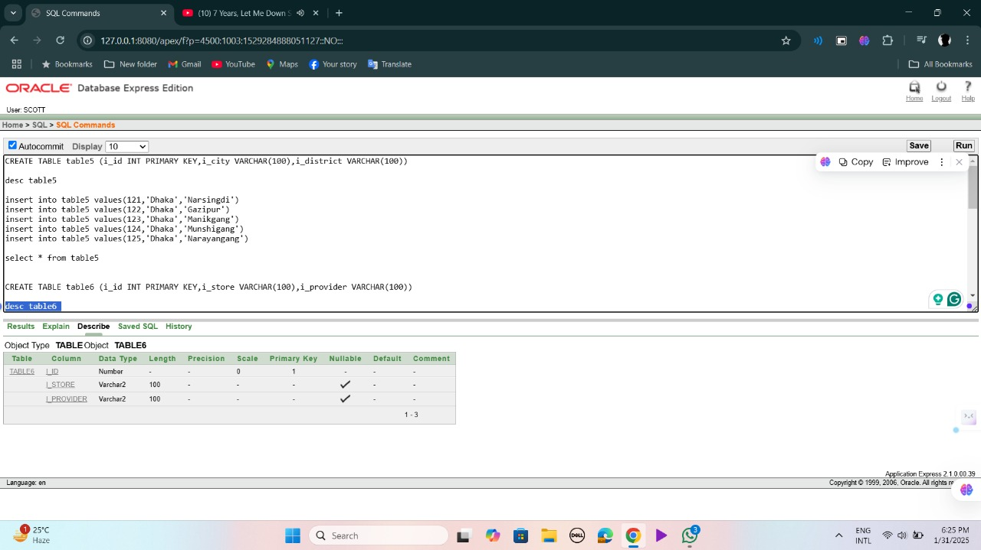

**TABLE-7**

CREATE table table7 (i_id INT PRIMARY KEY, i_phone VARCHAR(15))

DESC table7

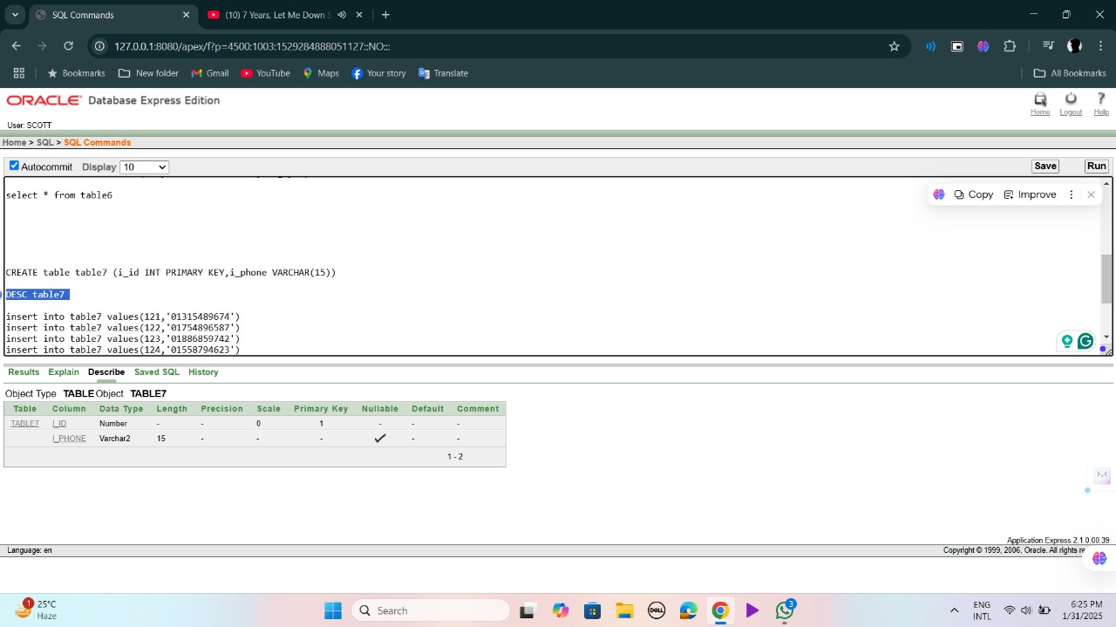

**TABLE-8**

-- Create table 8: Medical History

CREATE TABLE table_8 (

mh_history_id NUMBER PRIMARY KEY, -- Unique ID for medical history

t_cost INT, -- Treatment cost as integer

d_name VARCHAR2(100) -- Doctor's name

);

DESC table_8;

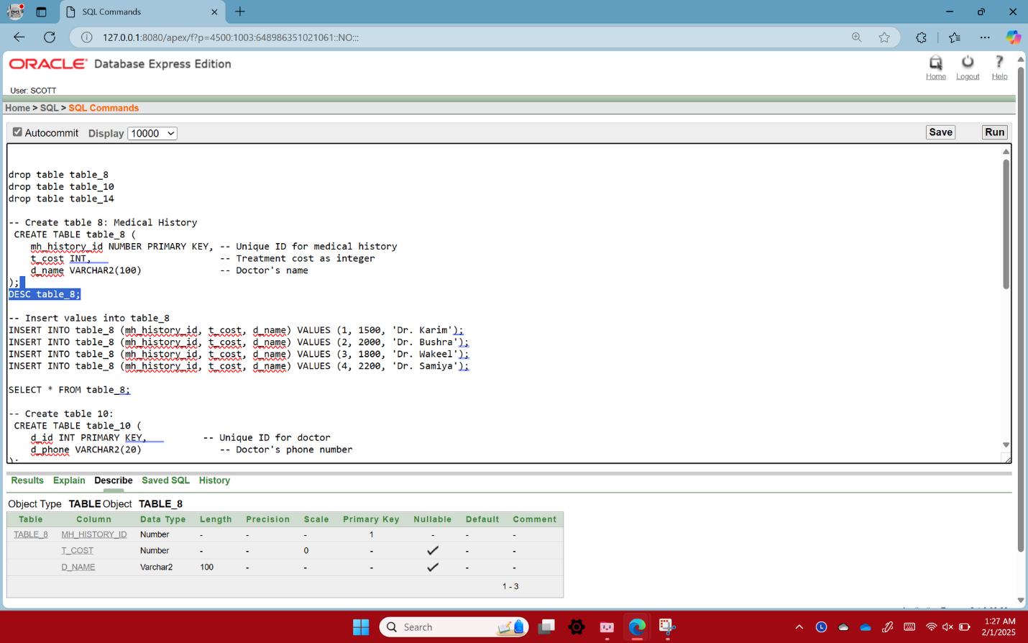

**TABLE-9**

create table table9(mh_history_id int primary key, mh_mc varchar2(500), mh_date date,p_id number(10,0),p_sn number(10,0),foreign key(p_sn) references table1(p_sn))

desc table9

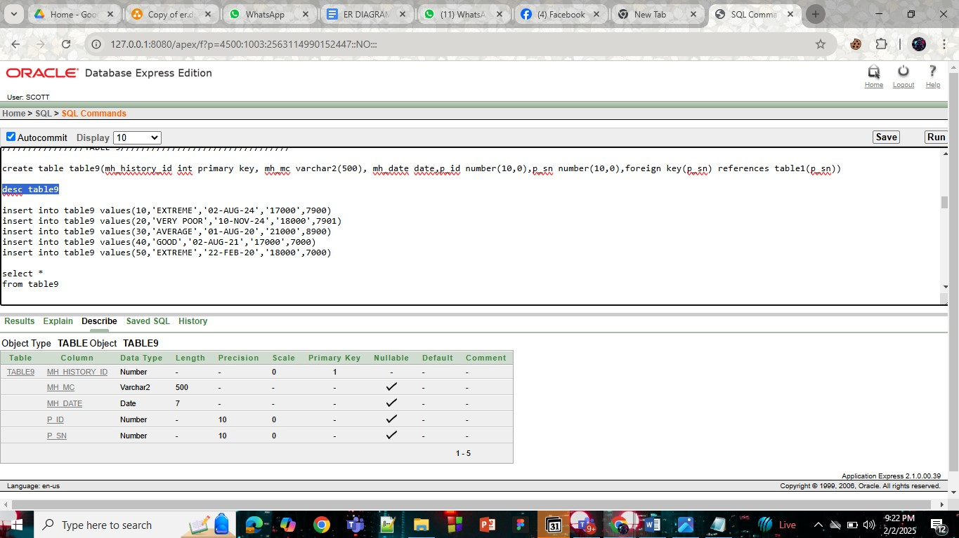

**TABLE-10**

-- Create table 10:

CREATE TABLE table_10 (

d_id INT PRIMARY KEY, -- Unique ID for doctor

d_phone VARCHAR2(20) -- Doctor's phone number

)

DESC table_10;

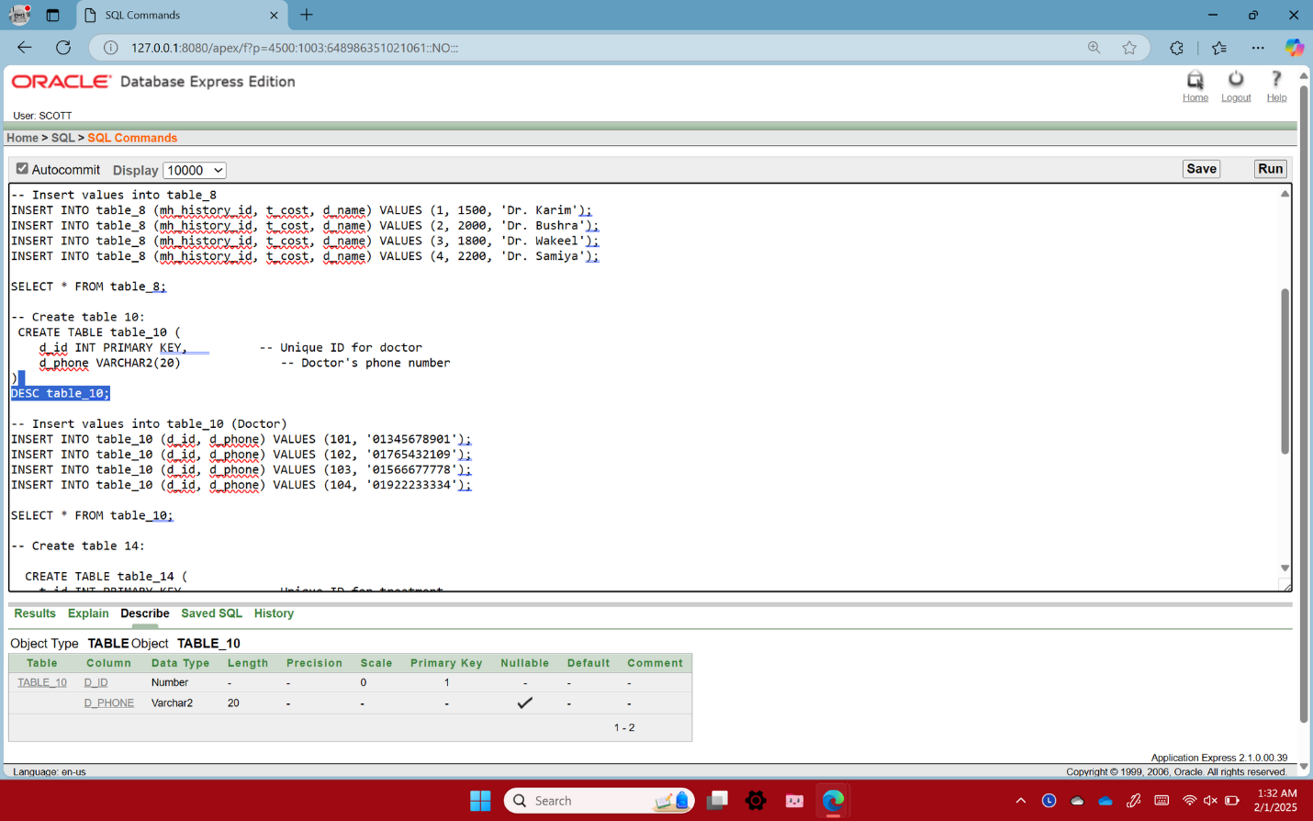

**TABLE-11**

create table table_11(d_id int primary key,d_city varchar2(10),d_district varchar2(20))

desc table_11

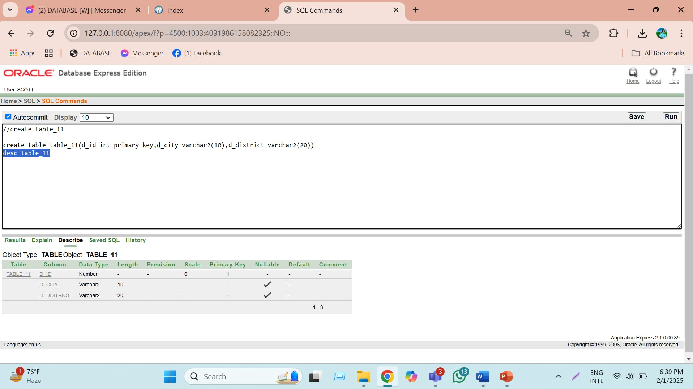

**TABLE-12**

create table table12(d_id int primary key,d_name varchar2(100),d_bonus number(10),d_hiredate date,p_sn number(10,0),foreign key(p_sn) references table1(p_sn))

desc table12

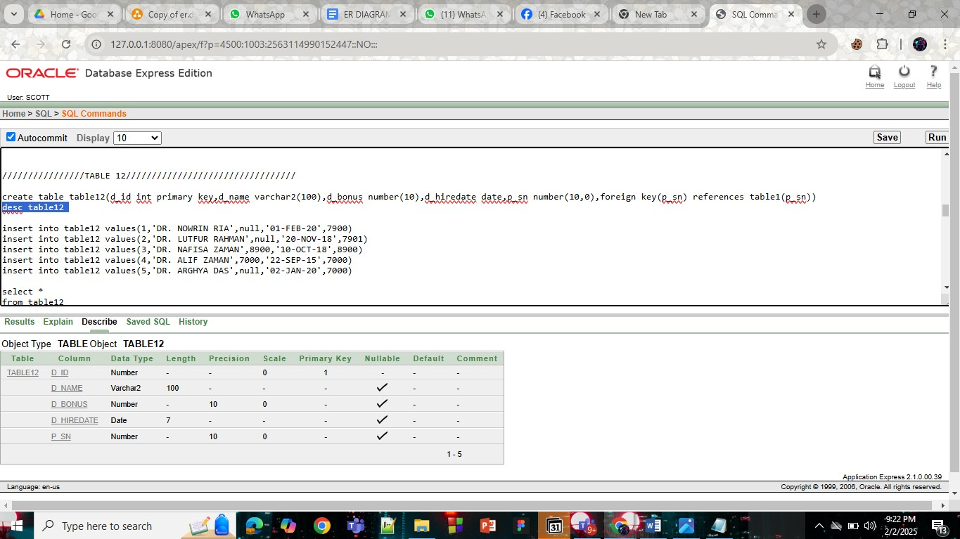

**TABLE-13**

create table table13(t_id int primary key,t_cost number(10),t_type varchar2(40),p_sn number(10,0),foreign key(p_sn) references table1(p_sn))

desc table13

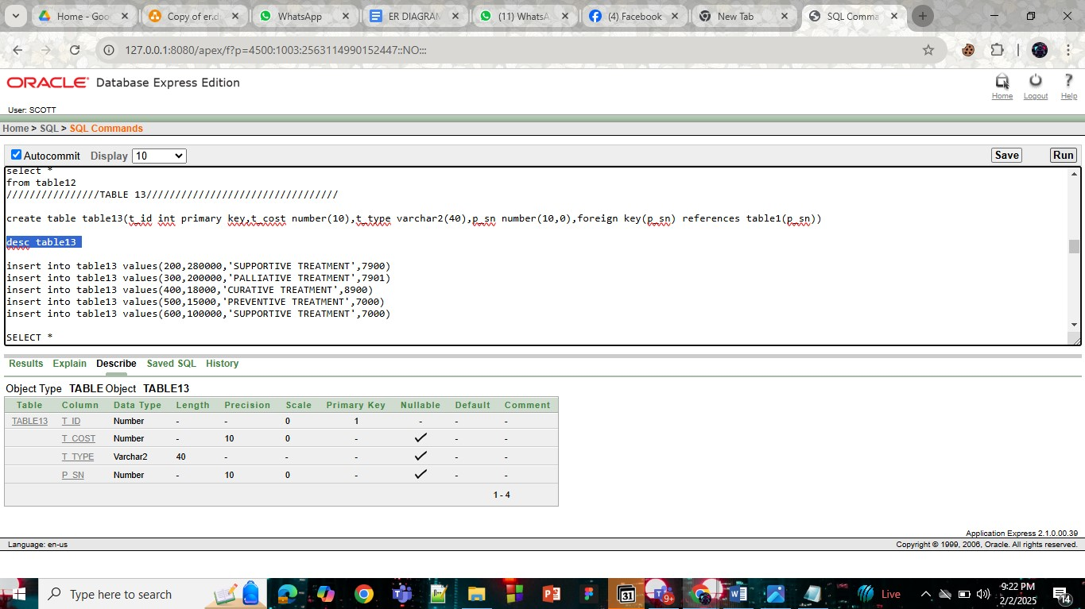

**TABLE-14**

-- Create table 14:

-- Create table 14:

CREATE TABLE table_14 (

t_id NUMBER PRIMARY KEY, -- Unique ID for treatment

t_cost INT, -- Treatment cost as integer

t_type VARCHAR2(50), -- Type of treatment (e.g., Surgery, Therapy)

d_id NUMBER, -- Doctor ID linked from table_10

CONSTRAINT fk_treatment_doctor FOREIGN KEY (d_id)

REFERENCES table_10(d_id) -- Foreign key constraint

);

DESC table_14; 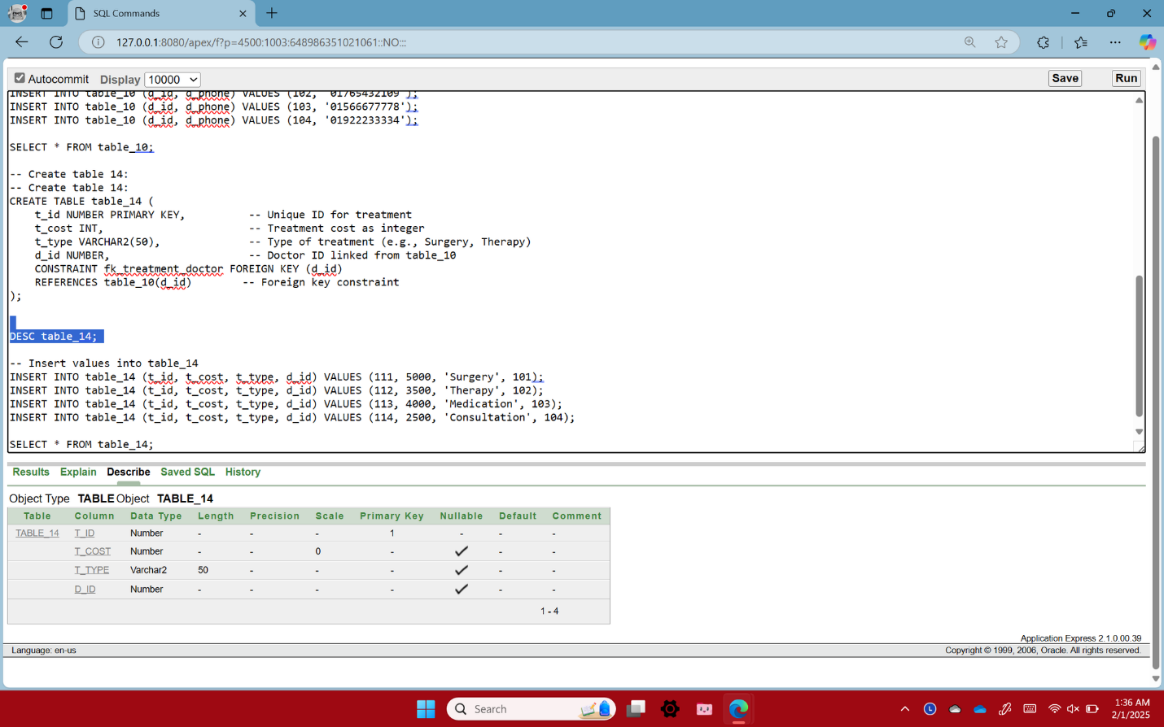

**TABLE-15**

create table table15(bill_id int primary key, f_transaction number(10,0),l_transaction number(10,0))

desc table15

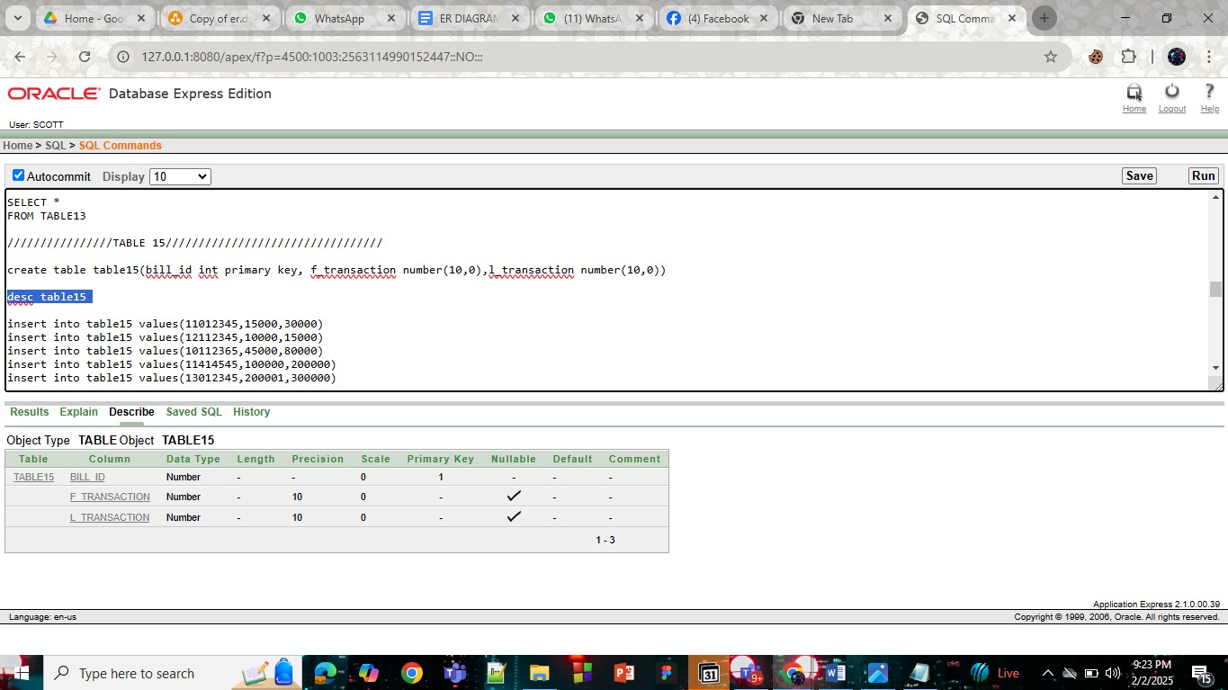

**TABLE-16**

create table table16(bill_id int primary key, bill_time varchar2(7),bill_date date,bill_name varchar2(100),p_sn number(10,0),foreign key(p_sn) references table2(p_sn))

desc table16

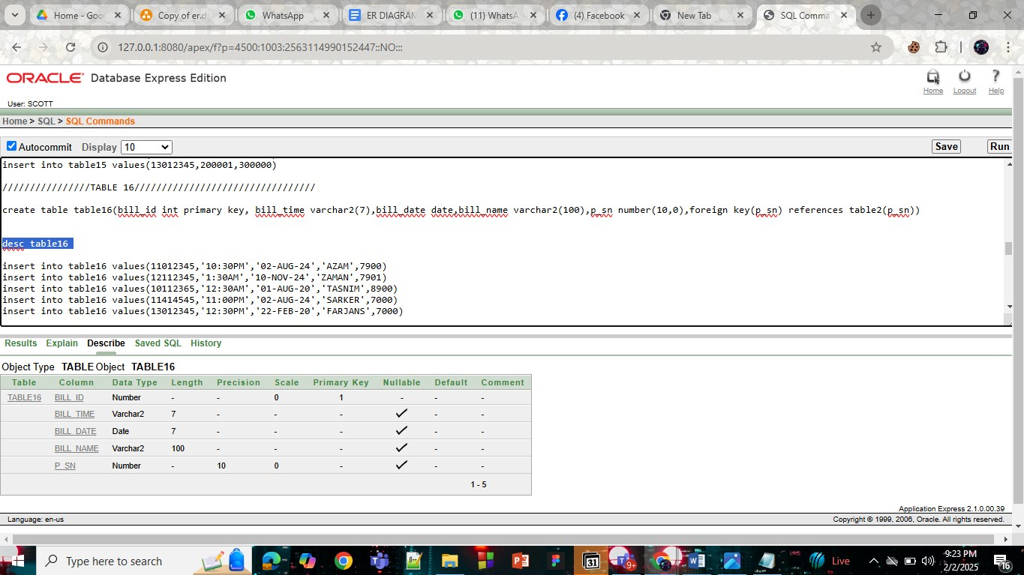

# **Inserted Values in the tables**

**TABLE-9**

**TABLE-1**

insert into table1 values(7900,01905058778)

insert into table1 values(7901,01753028631)

insert into table1 values(8900,01920802495)

insert into table1 values(7000,01884419143)

insert into table1 values(7800,01756028312)

select *

from table1

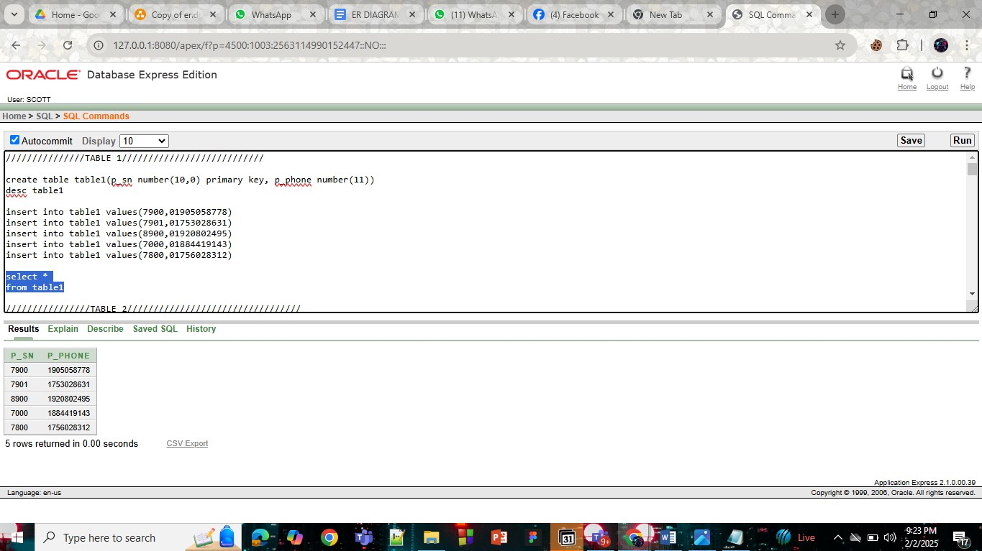

**TABLE-2**

insert into table2 values(7900,'UTTARA','DHAKA')

insert into table2 values(7901,'DHANMANDI','DHAKA')

insert into table2 values(8900,'BASHUNDHARA','DHAKA')

insert into table2 values(7000,'MOHAKHALI','DHAKA')

insert into table2 values(7800,'TONGI','GAZIPUR')

select *

from table2

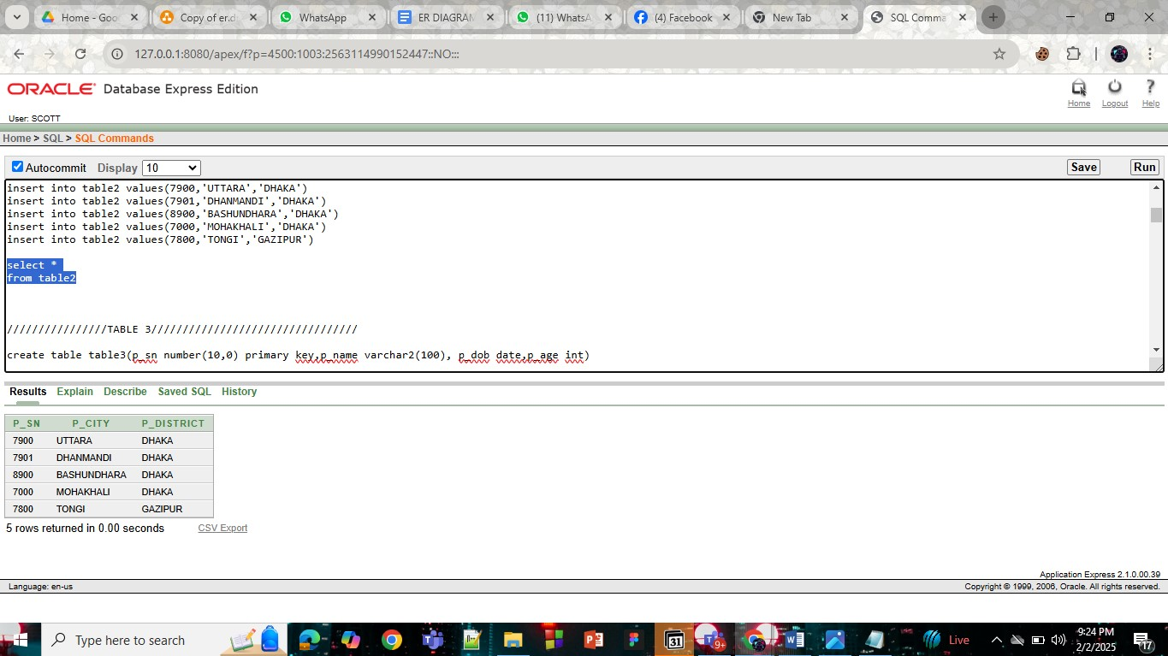

**TABLE-3**

insert into table3 values(7900,'SANJIDA','08-JUL-06',19)

insert into table3 values(7901,'ALIF','13-NOV-04',21)

insert into table3 values(8900,'ARGHYA','11-JAN-03',22)

insert into table3 values(7000,'WASEE','06-FEB-20',5)

insert into table3 values(7800,'RAAHIL','08-MAR-19',6)

select *

from table3

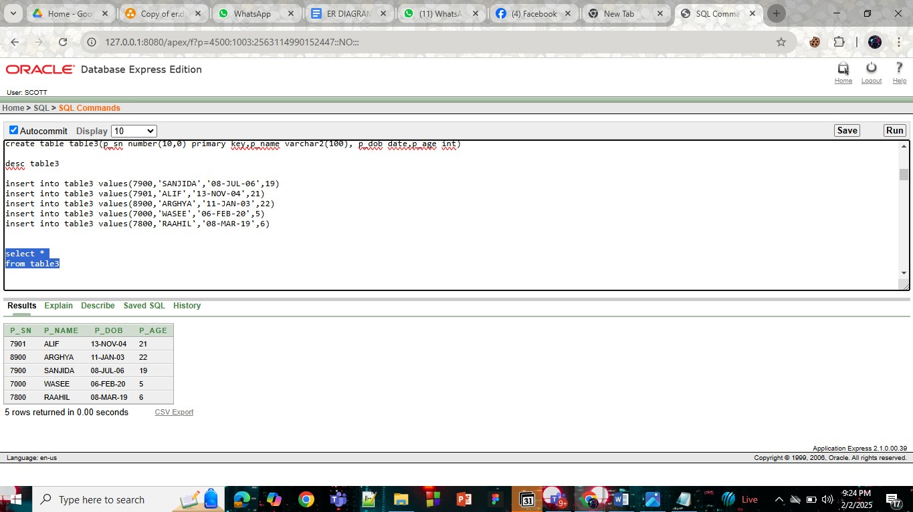

**TABLE-4**

insert into table4 values(101,'02-AUG-24','DR. NOWRIN RIA','8:00AM',7900)

insert into table4 values(102,'10-NOV-24','DR. LUTFUR RAHMAN','9:30PM',7901)

insert into table4 values(103,'01-AUG-20','DR. NAFISA ZAMAN','10:40PM',8900)

insert into table4 values(104,'02-AUG-21','DR. ALIF ZAMAN','10:00AM',7000)

insert into table4 values(105,'22-FEB-20','DR. ARGHYA DAS','8:00AM',7000)

select *

from table4

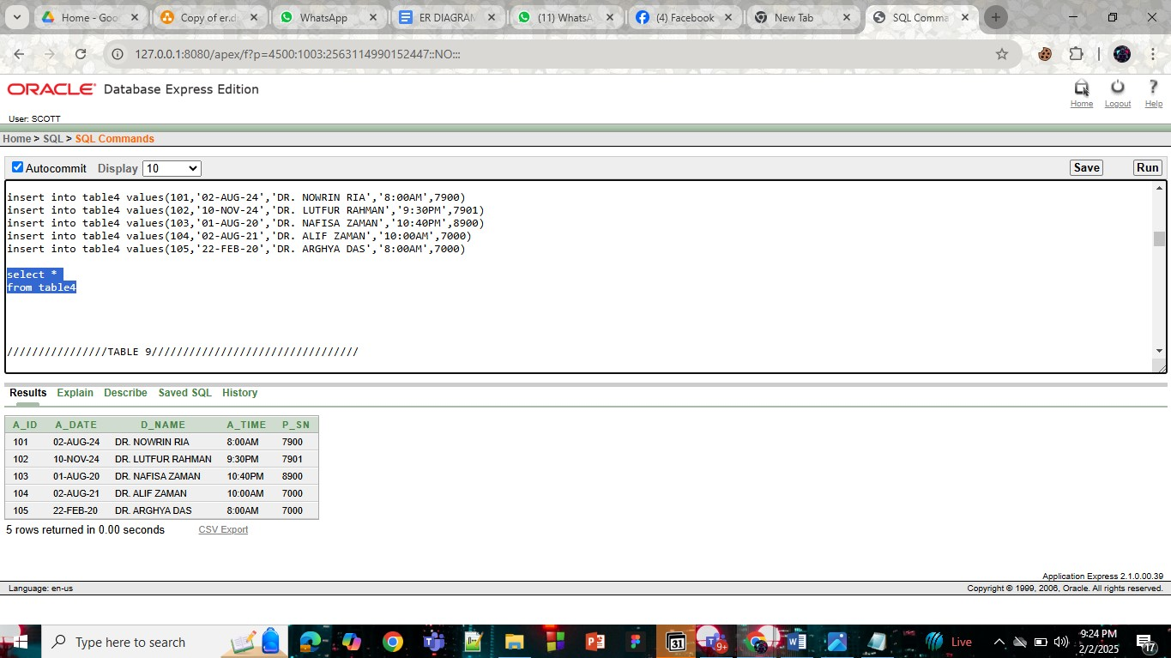

**TABLE-5**

insert into table5 values (121, 'Dhaka', 'Narsingdi')

insert into table5 values (122, 'Dhaka', 'Gazipur')

insert into table5 values (123, 'Dhaka', 'Manikganj')

insert into table5 values (124, 'Dhaka', 'Munshiganj')

insert into table5 values (125, 'Dhaka', 'Narayanganj')

select * from table5

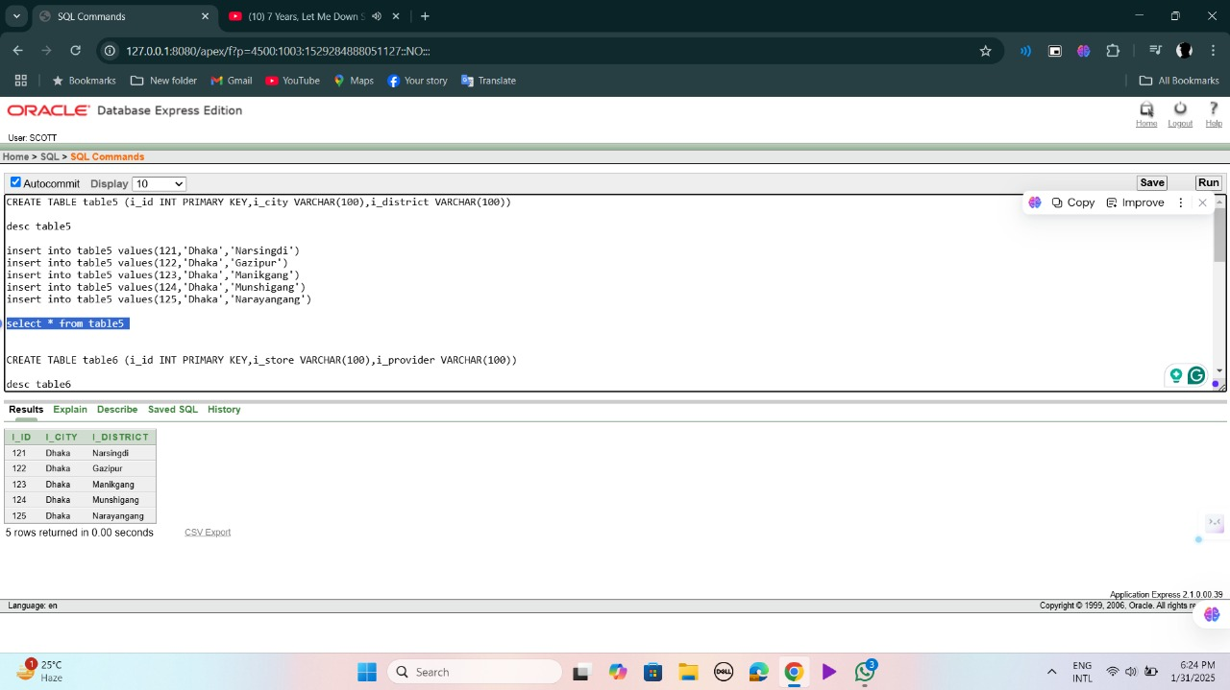

**TABLE-6**

insert into table6 values (121, 'cure option', 'Ankon')

insert into table6 values (122, 'cure fram', 'Ananta')

insert into table6 values (123, 'Medi life', 'Tasfia')

insert into table6 values (124, 'Medi eye', 'Alif')

insert into table6 values (125, 'Cure and Phrama', 'Arghya')

select * from table6

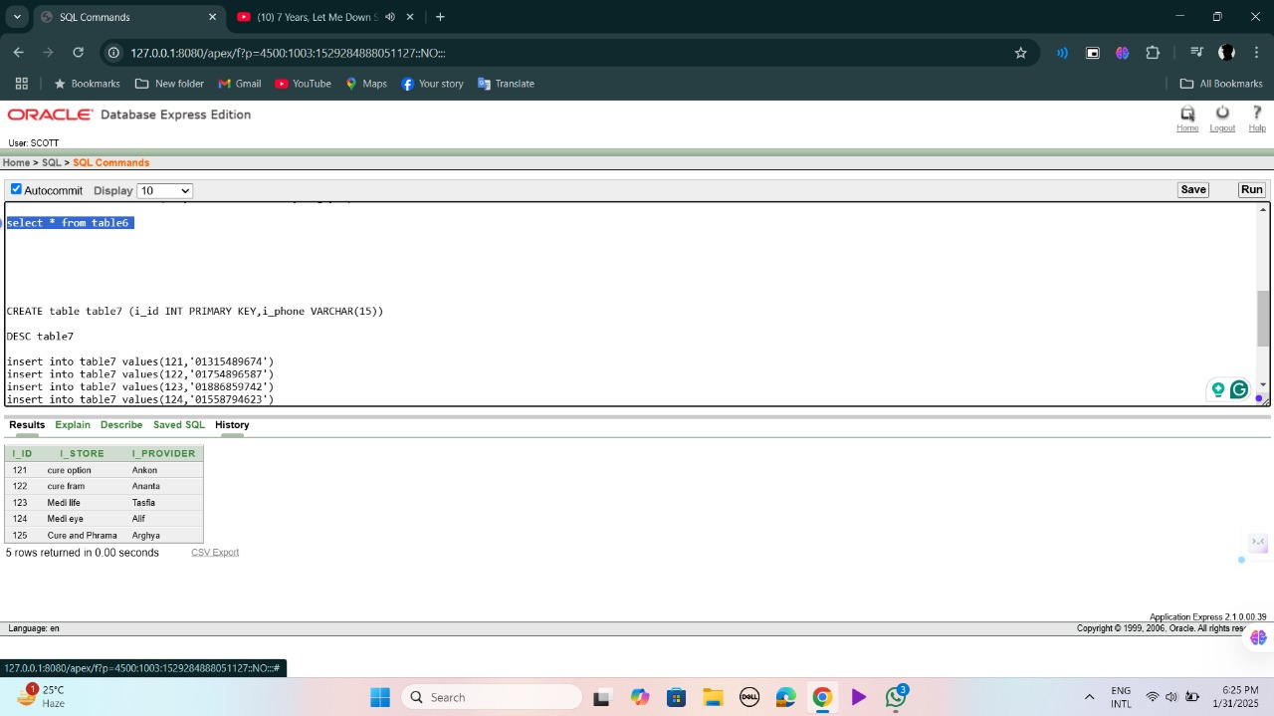

**TABLE-7**

insert into table7 values(121, '01315489674')

insert into table7 values(122, '01754896587')

insert into table7 values(123, '01886859742')

insert into table7 values(124, '01558794623')

insert into table7 values(125, '01387478985')

select * from table7

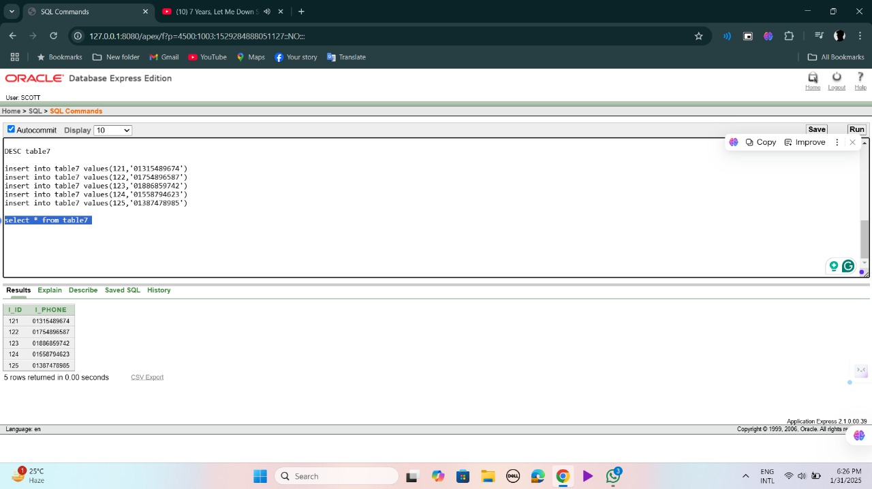

**TABLE-8**

INSERT INTO table_8 (mh_history_id, t_cost, d_name) VALUES (1, 1500, 'Dr. Karim');

INSERT INTO table_8 (mh_history_id, t_cost, d_name) VALUES (2, 2000, 'Dr. Bushra');

INSERT INTO table_8 (mh_history_id, t_cost, d_name) VALUES (3, 1800, 'Dr. Wakeel');

INSERT INTO table_8 (mh_history_id, t_cost, d_name) VALUES (4, 2200, 'Dr. Samiya');

SELECT * FROM table_8;

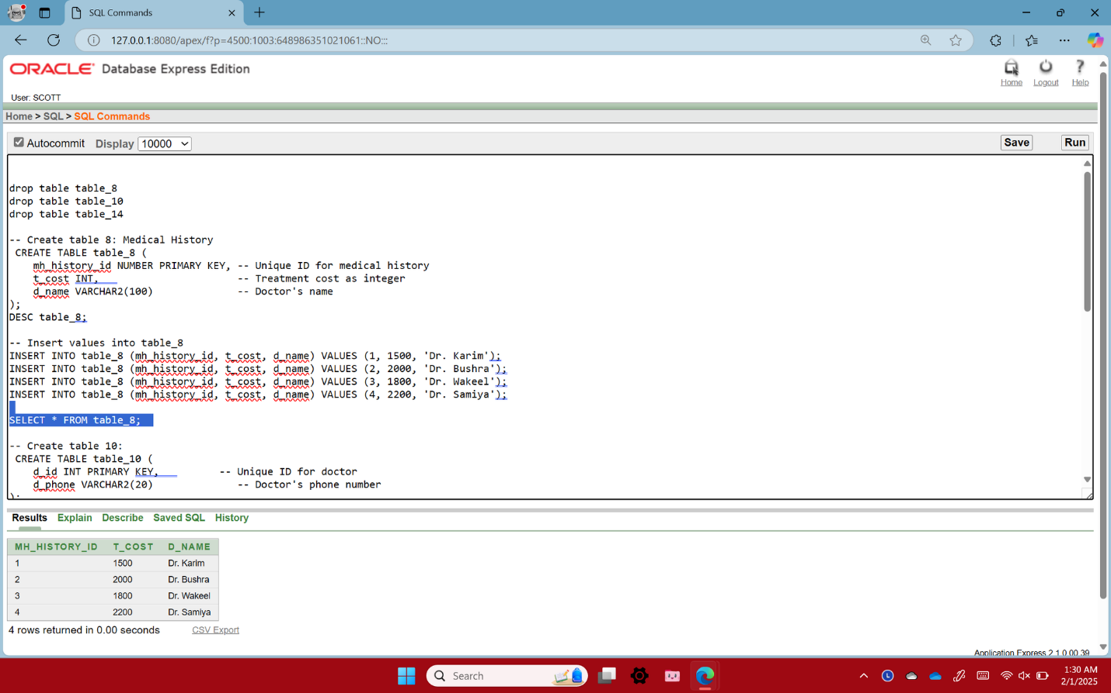

**TABLE-9**

insert into table9 values(10,'EXTREME','02-AUG-24','17000',7900)

insert into table9 values(20,'VERY POOR','10-NOV-24','18000',7901)

insert into table9 values(30,'AVERAGE','01-AUG-20','21000',8900)

insert into table9 values(40,'GOOD','02-AUG-21','17000',7000)

insert into table9 values(50,'EXTREME','22-FEB-20','18000',7000)

select *

from table9

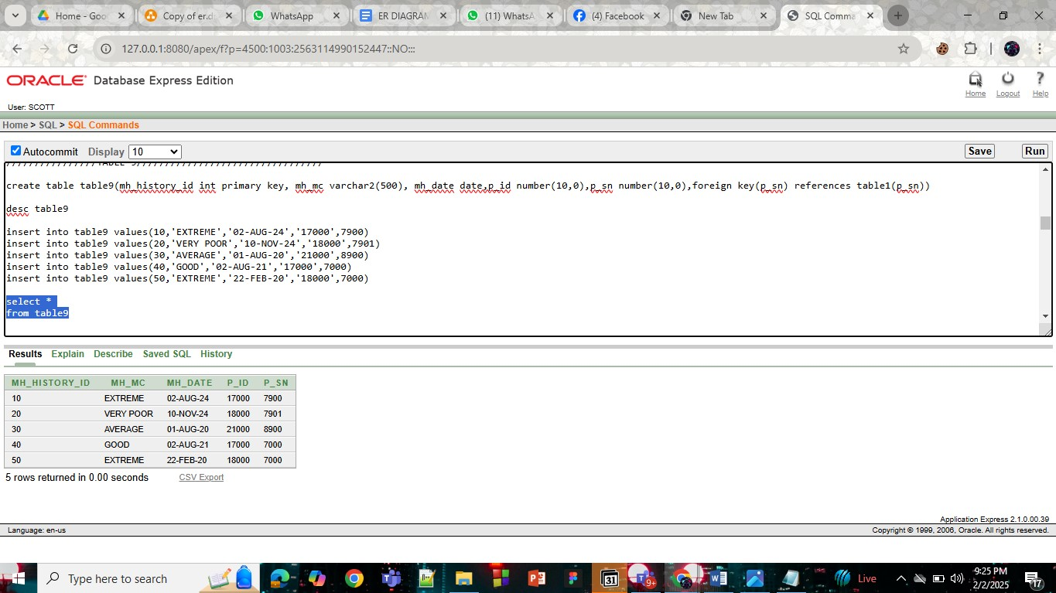

**TABLE-10**

INSERT INTO table_10 (d_id, d_phone) VALUES (101, '01345678901');

INSERT INTO table_10 (d_id, d_phone) VALUES (102, '01765432109');

INSERT INTO table_10 (d_id, d_phone) VALUES (103, '01566677778');

INSERT INTO table_10 (d_id, d_phone) VALUES (104, '01922233334');

SELECT * FROM table_10;

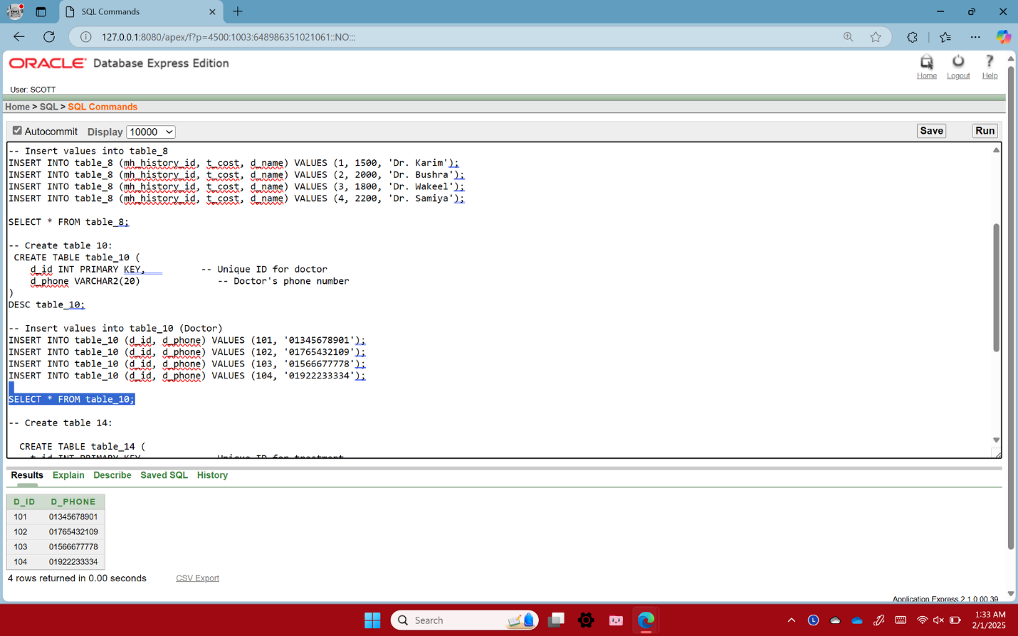

**TABLE-11**

insert into table_11 values(1,'Dhaka', 'Dhaka')

insert into table_11 values(2,'Chittagong', 'Chittagong')

insert into table_11 values(3, 'Khulna', 'Khulna');

insert into table_11 values(4, 'Sylhet', 'Sylhet');

insert into table_11 values(5, 'Rajshahi', 'Rajshahi');

select * from table_11

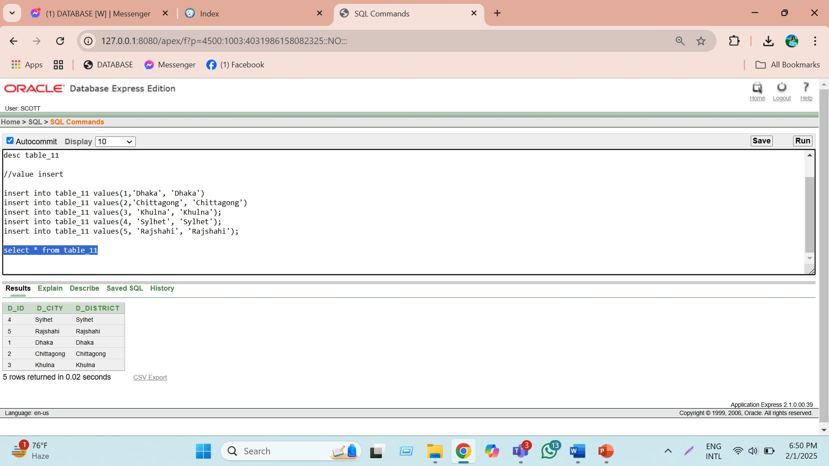

**TABLE-12**

insert into table12 values(1,'DR. NOWRIN RIA',null,'01-FEB-20',7900)

insert into table12 values(2,'DR. LUTFUR RAHMAN',null,'20-NOV-18',7901)

insert into table12 values(3,'DR. NAFISA ZAMAN',8900,'10-OCT-18',8900)

insert into table12 values(4,'DR. ALIF ZAMAN',7000,'22-SEP-15',7000)

insert into table12 values(5,'DR. ARGHYA DAS',null,'02-JAN-20',7000)

select *

from table12

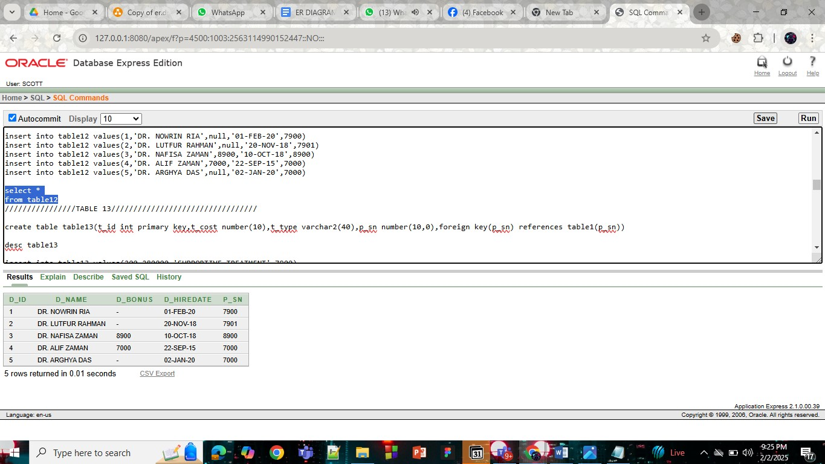

**TABLE-13**

insert into table13 values(200,280000,'SUPPORTIVE TREATMENT',7900)

insert into table13 values(300,200000,'PALLIATIVE TREATMENT',7901)

insert into table13 values(400,18000,'CURATIVE TREATMENT',8900)

insert into table13 values(500,15000,'PREVENTIVE TREATMENT',7000)

insert into table13 values(600,100000,'SUPPORTIVE TREATMENT',7000)

SELECT *

FROM TABLE13

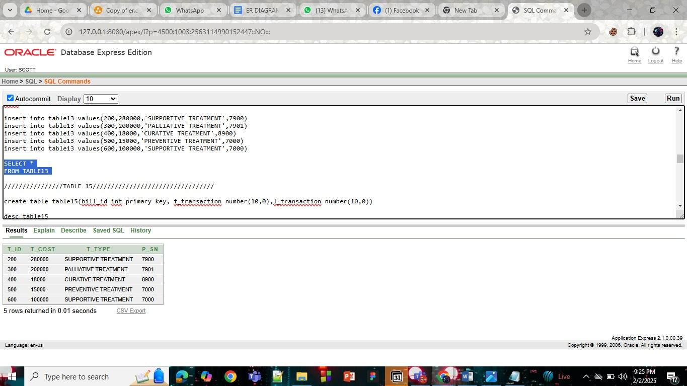

**TABLE-14**

INSERT INTO table_14 (t_id, t_cost, t_type, d_id) VALUES (111, 5000, 'Surgery', 101);

INSERT INTO table_14 (t_id, t_cost, t_type, d_id) VALUES (112, 3500, 'Therapy', 102);

INSERT INTO table_14 (t_id, t_cost, t_type, d_id) VALUES (113, 4000, 'Medication', 103);

INSERT INTO table_14 (t_id, t_cost, t_type, d_id) VALUES (114, 2500, 'Consultation', 104);

SELECT * FROM table_14;

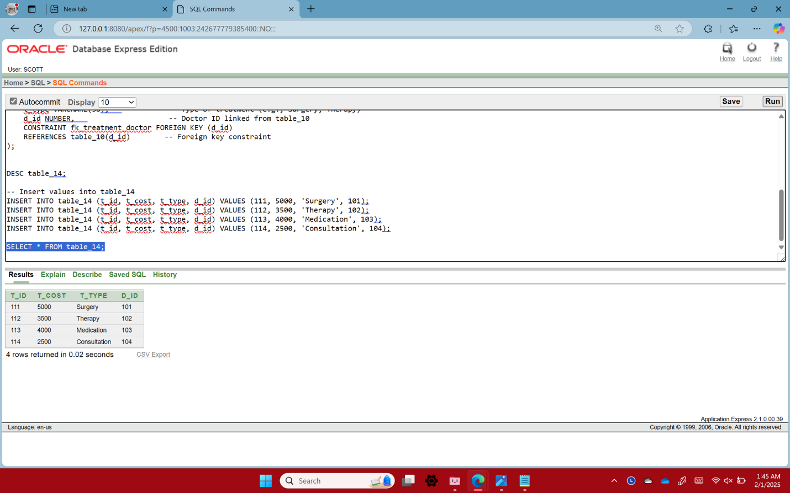

**TABLE-15**

insert into table15 values(11012345,15000,30000)

insert into table15 values(12112345,10000,15000)

insert into table15 values(10112365,45000,80000)

insert into table15 values(11414545,100000,200000)

insert into table15 values(13012345,200001,300000)

select * from table15

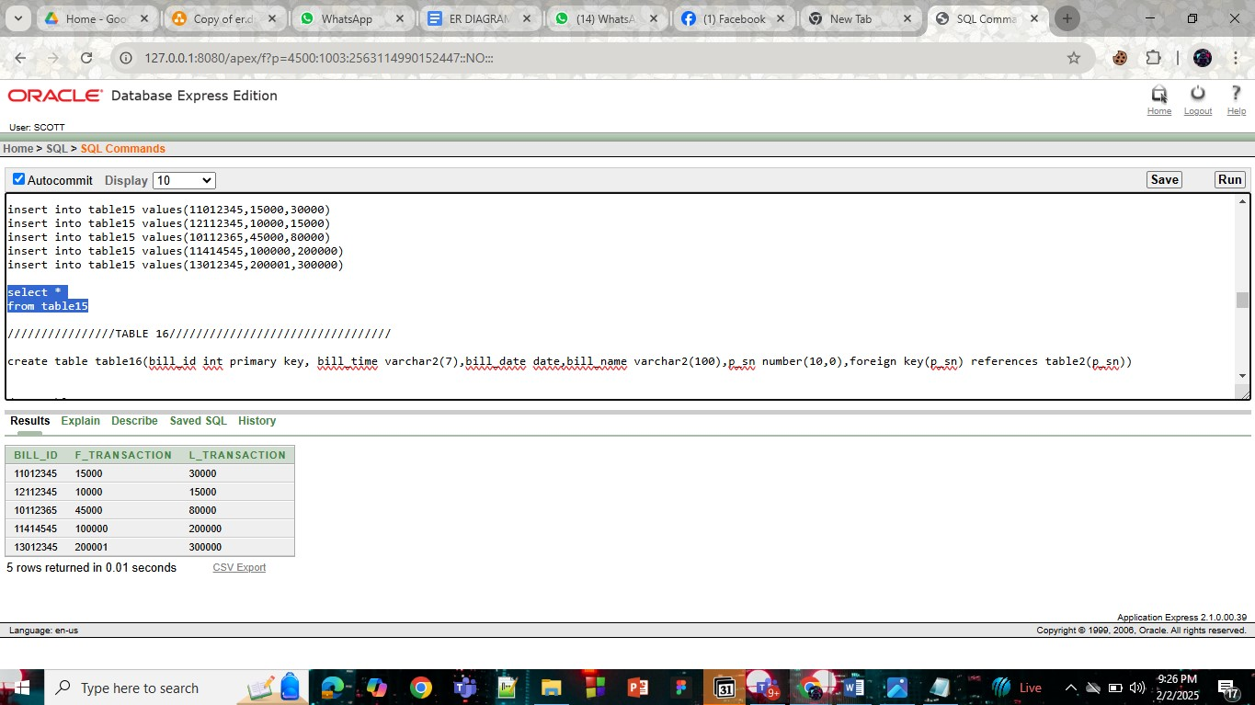

**TABLE-16**

insert into table16 values(11012345,'10:30PM','02-AUG-24','AZAM',7900)

insert into table16 values(12112345,'1:30AM','10-NOV-24','ZAMAN',7901)

insert into table16 values(10112365,'12:30AM','01-AUG-20','TASNIM',8900)

insert into table16 values(11414545,'11:00PM','02-AUG-24','SARKER',7000)

insert into table16 values(13012345,'12:30PM','22-FEB-20','FARJANS',7000)

SELECT *

FROM TABLE16

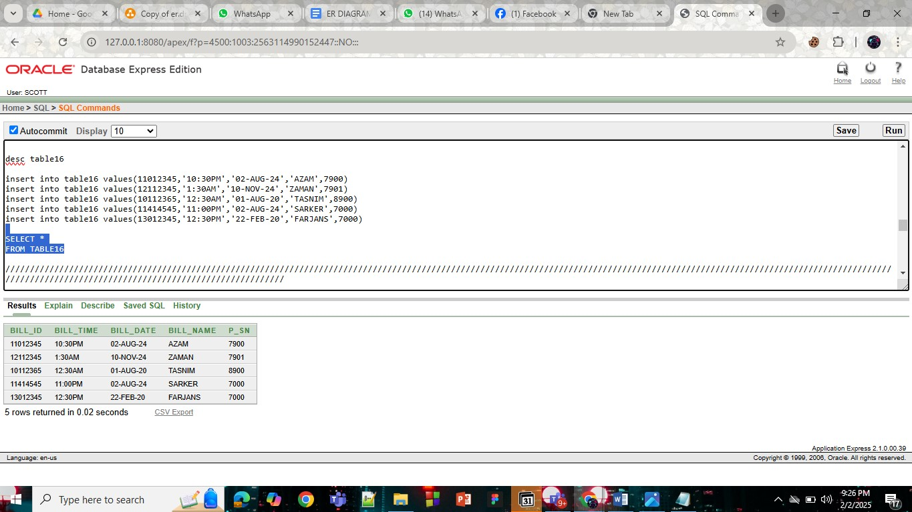

# **Query Test in DB**

* 1. **Display the table12 information**

select *

from table12

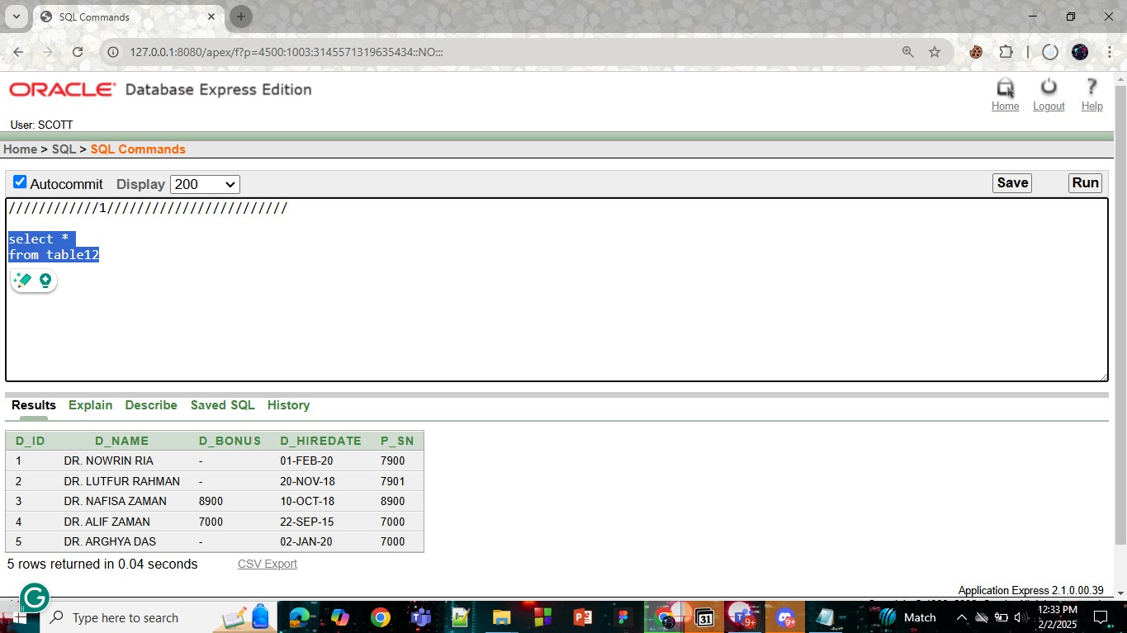

* 1. **Display lower case of doctor name in table4**

select lower(d_name)

from table4

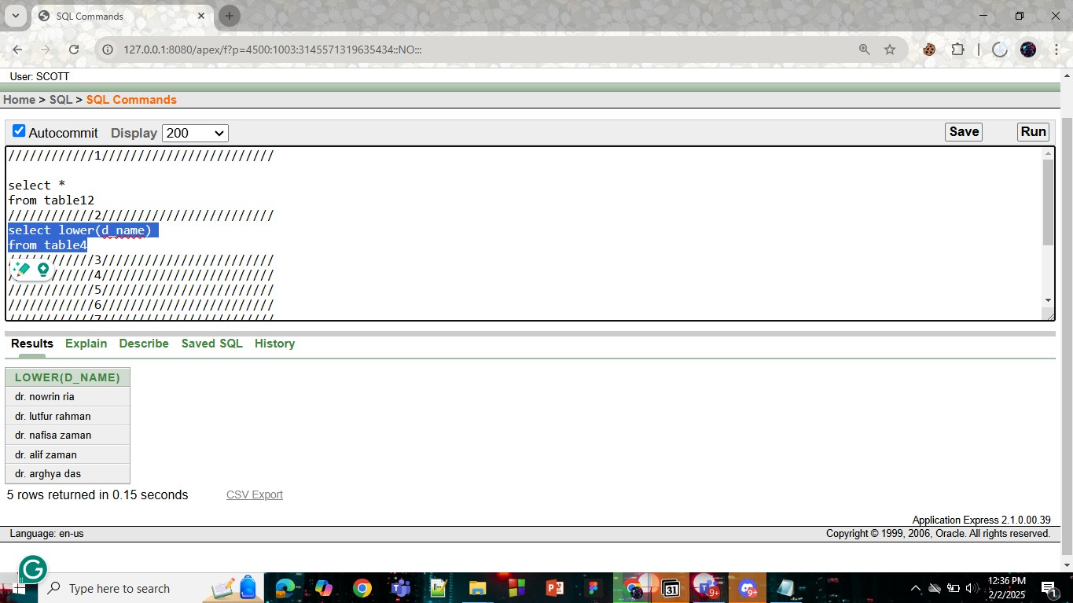

* 1. **Display rounded Average salary of f_transaction in table15**

select round(avg(f_transaction))

from table15

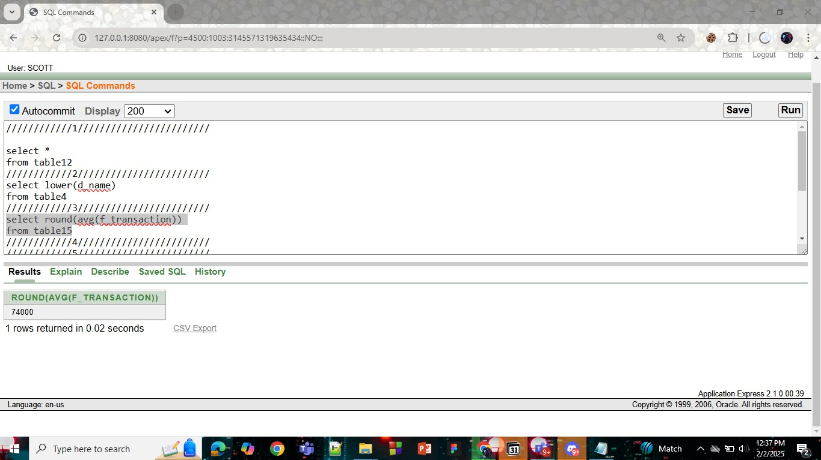

* 1. **Display the doctor name,appointment id,date,time of patient sanjida**

select a_id,d_name,a_date,a_time

from table4

where p_sn=(select p_sn

from table3

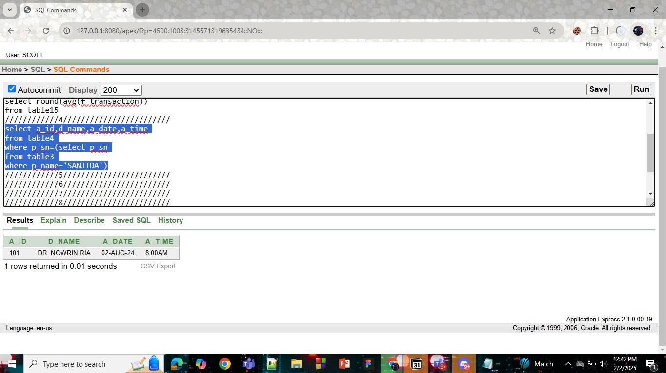

* 1. **Display the mh_history_id,mh_mc, of patient arghya**

select mh_history_id,mh_mc

from table9

where p_sn=(select p_sn

from table3

where p_name='ARGHYA')

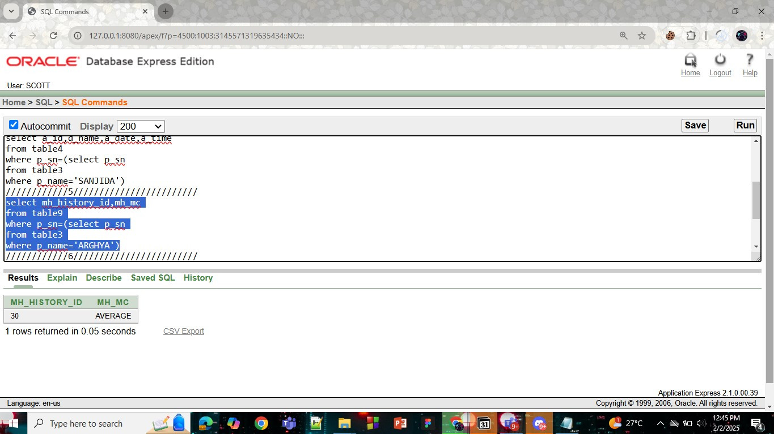

* 1. **Display the bill f_transaction and l_transaction which is greater than average of tretament cost**

select f_transaction,l_transaction

from table15

where f_transaction>(select avg(t_cost)

from table13

) or l_transaction>(select avg(t_cost)

from table13)

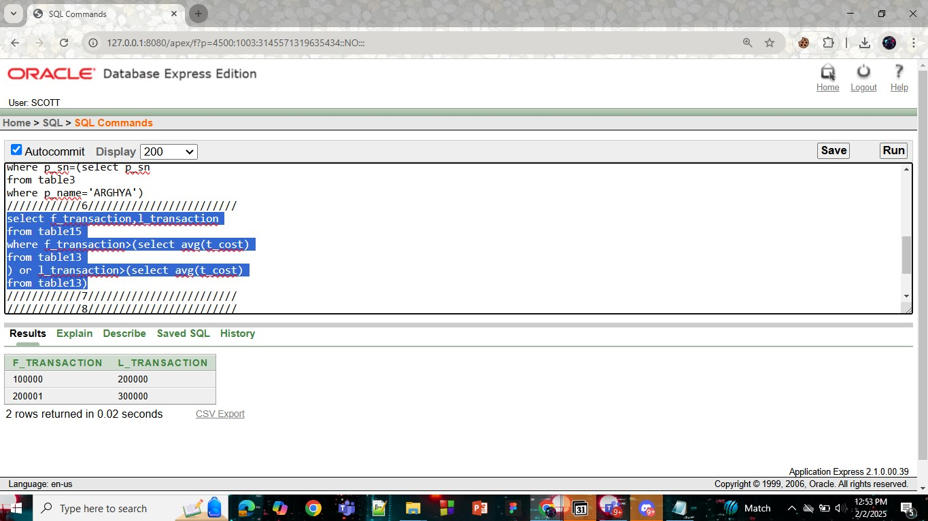

* 1. **Display the bill f_transaction and l_transaction which is less than sum of treatment cost**

select f_transaction,l_transaction

from table15

where f_transaction<(select sum(t_cost)

from table13

) or l_transaction<(select sum(t_cost)

from table13)

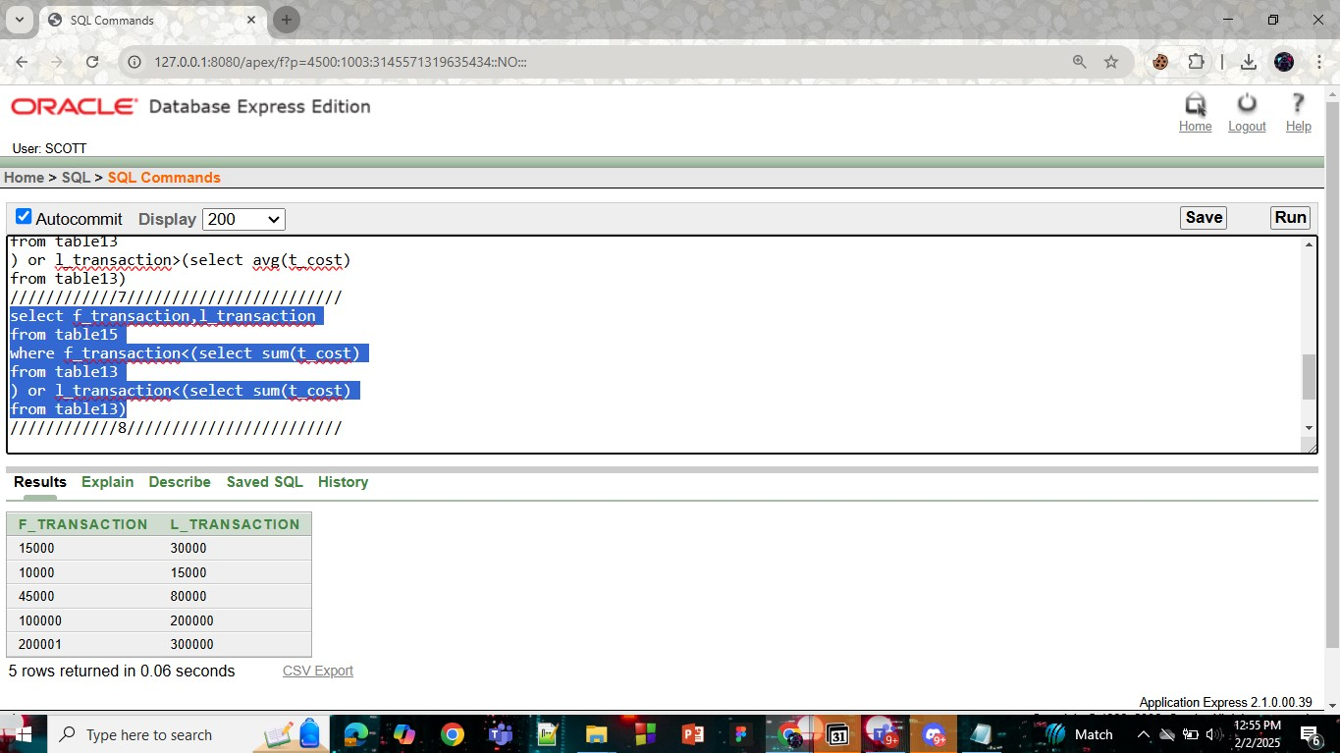

* 1. **Display the patient name, patient condition,appointment date,appointment time by using joining**

select t3.p_name,t9.mh_mc,t4.a_date,t4.a_time

from table9 t9,table4 t4,table3 t3

where (t3.p_sn=t9.p_sn) and (t3.p_sn=t4.p_sn)

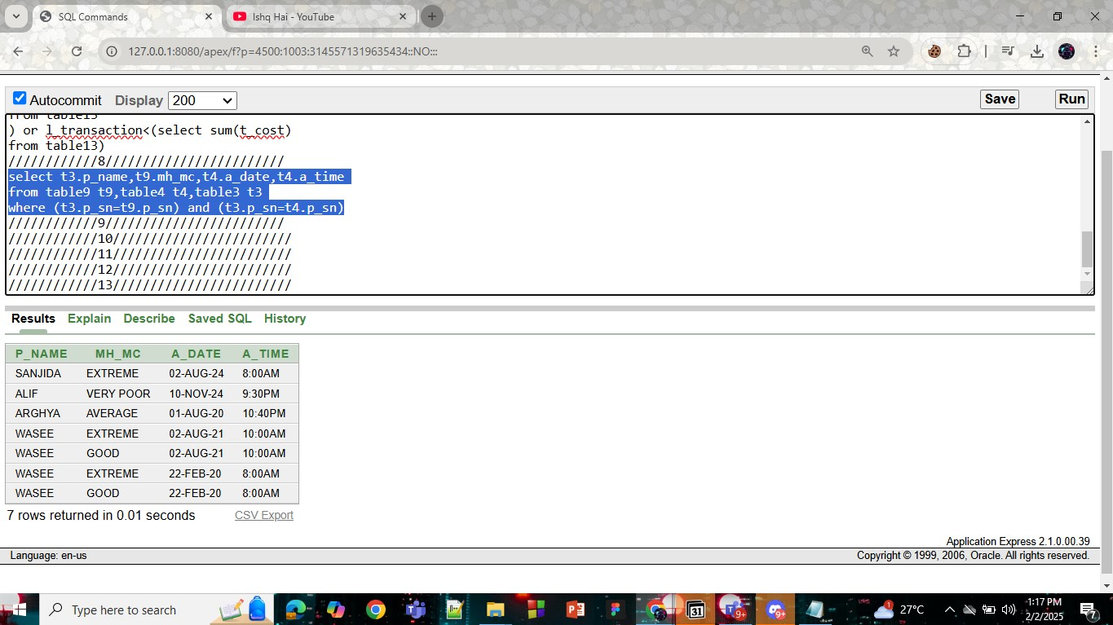

* 1. **Display the patient name, patient condition,appointment date,appointment time and if there is any patient serial number is not present display 'NO PATIENT' by using joining**

select t3.p_name,nvl(to_char(t9.mh_mc),'NO INFORMATION'),t4.a_date,t4.a_time,t3.p_sn

from table9 t9,table4 t4, table3 t3

where t9.p_sn(+)=t3.p_sn

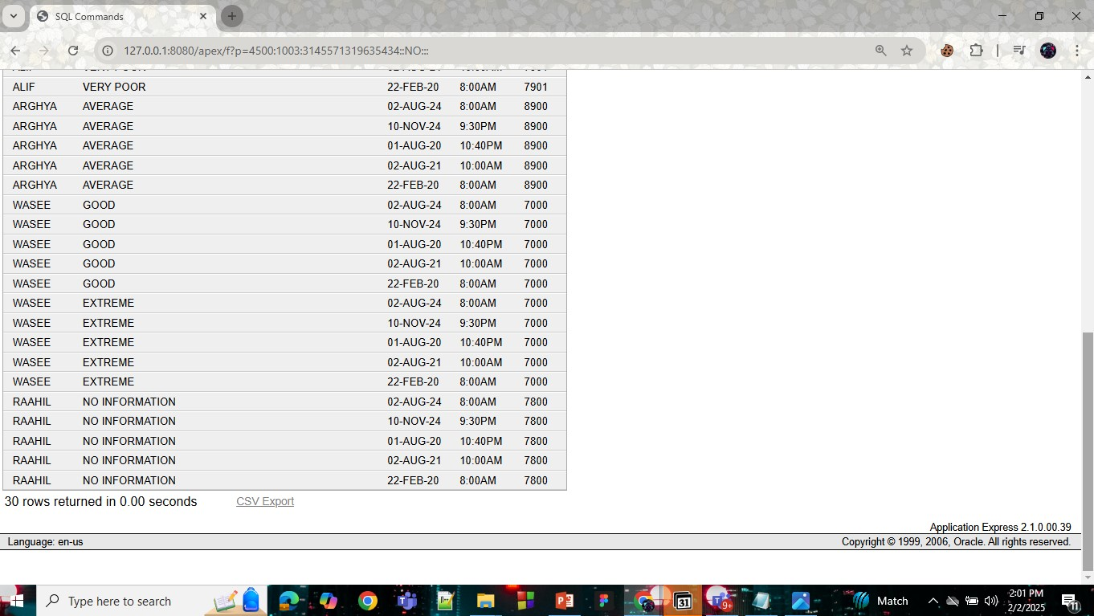

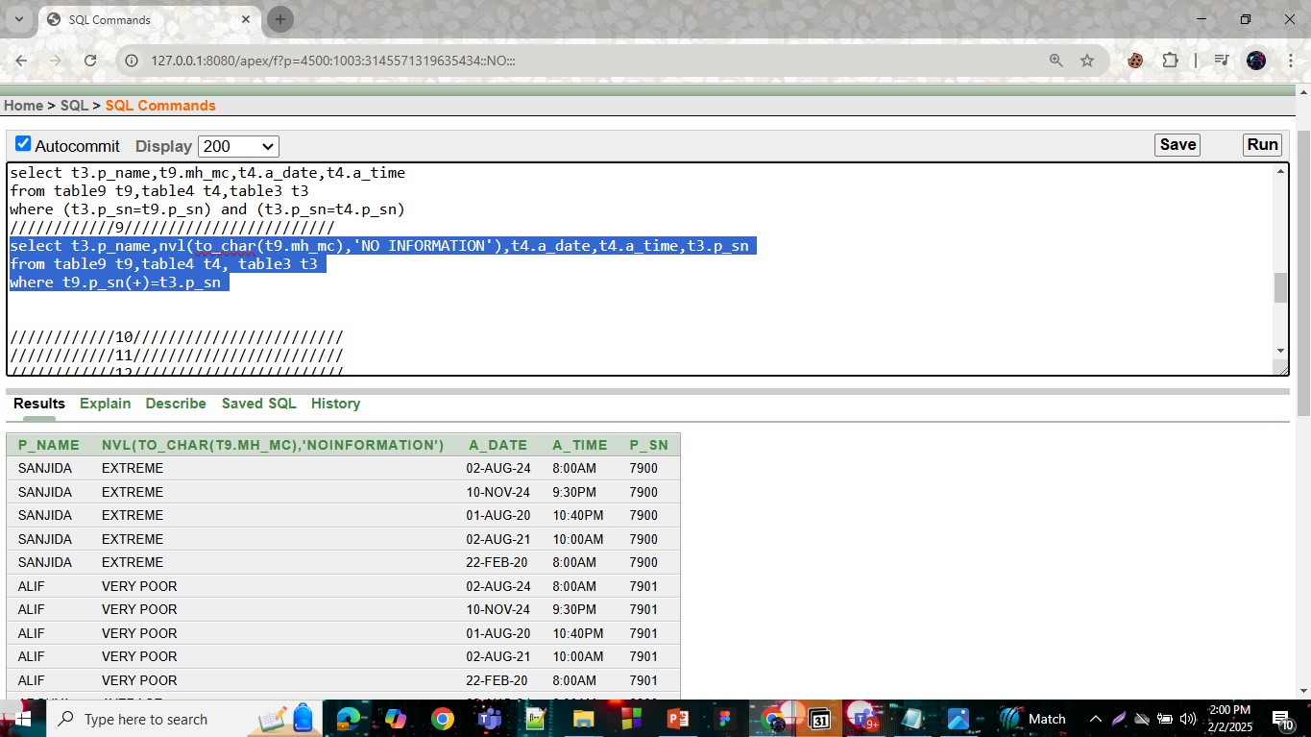

* 1. **Display the treatment cost between f_transaction and l_transaction by using joining**

select t13.t_cost

from table13 t13,table15 t15

where t_cost between t15.f_transaction and l_transaction

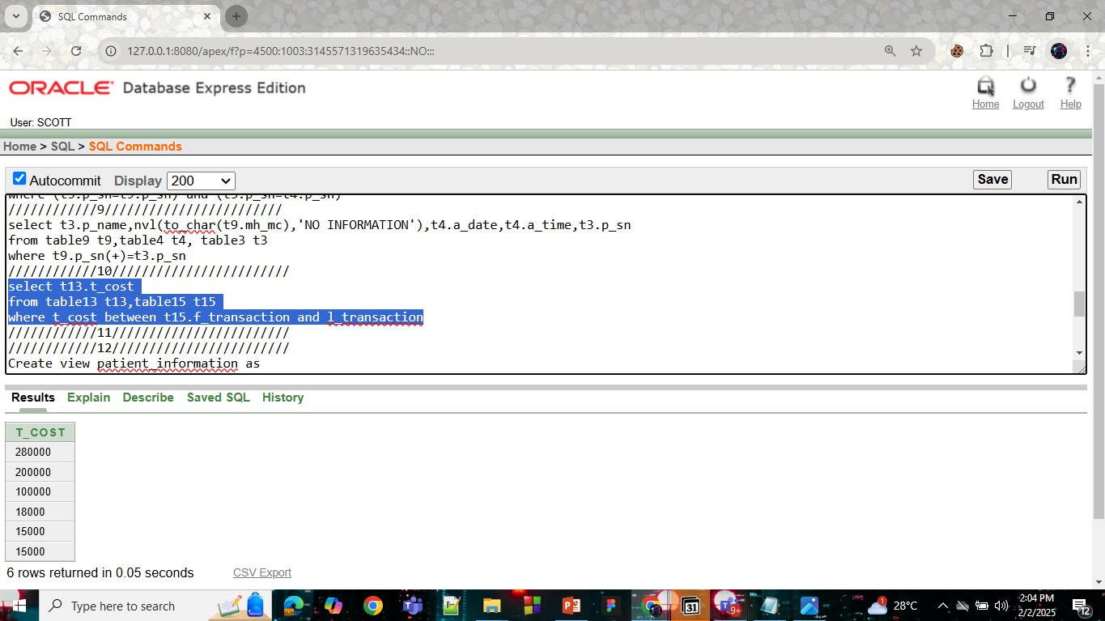

* 1. **Display table12 of the doctor information if d_bonus is equal to patient serial number(p_sn) by using joining**

select t1.d_name,t2.p_sn

from table12 t1, table12 t2

where t1.d_bonus=t2.p_sn

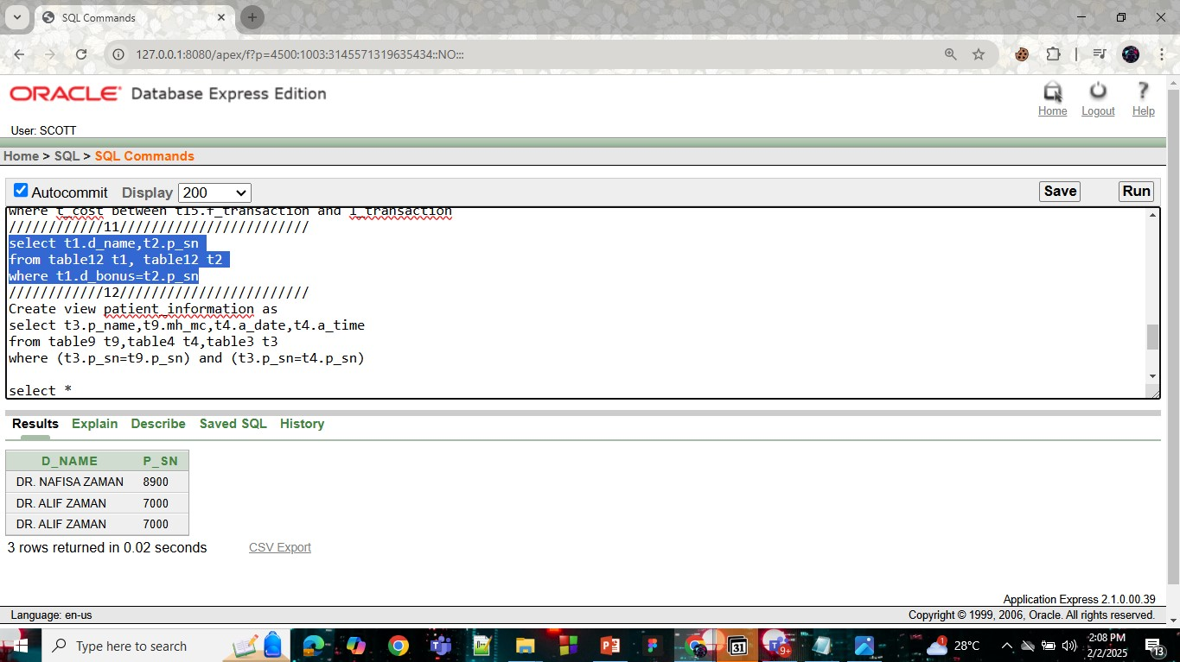

* 1. **Create a table patient name, patient condition,appointment date,appointment time and name as 'PATIENT_INFORMATION'**

Create view patient_information as

select t3.p_name,t9.mh_mc,t4.a_date,t4.a_time

from table9 t9,table4 t4,table3 t3

where (t3.p_sn=t9.p_sn) and (t3.p_sn=t4.p_sn)

select *

from patient_information

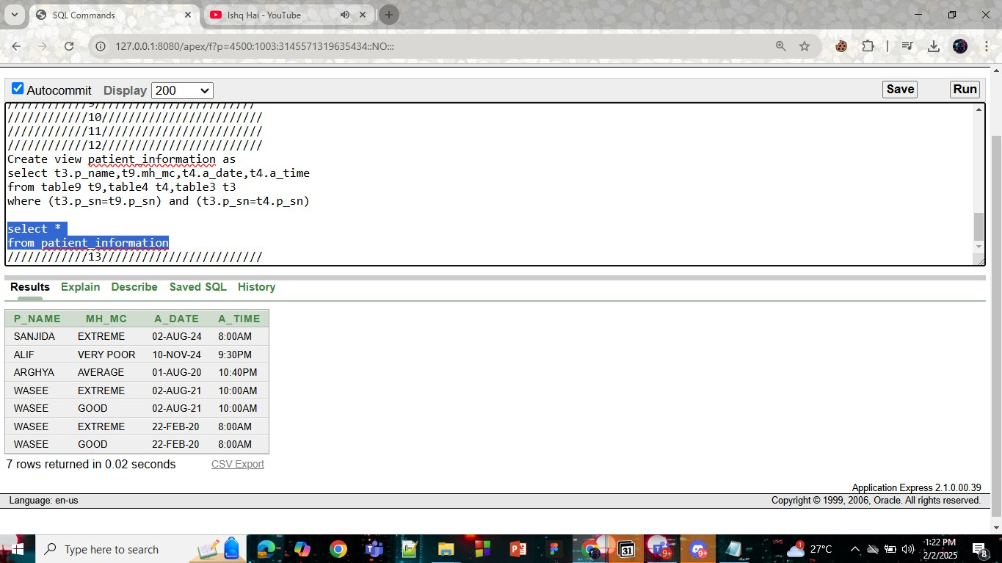

* 1. **Create a treatment table of avg t_cost,sum t_cost, min t_cost and max t_cost and named as 'TREATMENT_COST'**

CREATE VIEW treatment_information(id,avgcost,scost,mincost,maxcost) as

select t_id,avg(t_cost),sum(t_cost),min(t_cost),max(t_cost)

from table13

group by t_id

select *

from treatment_information

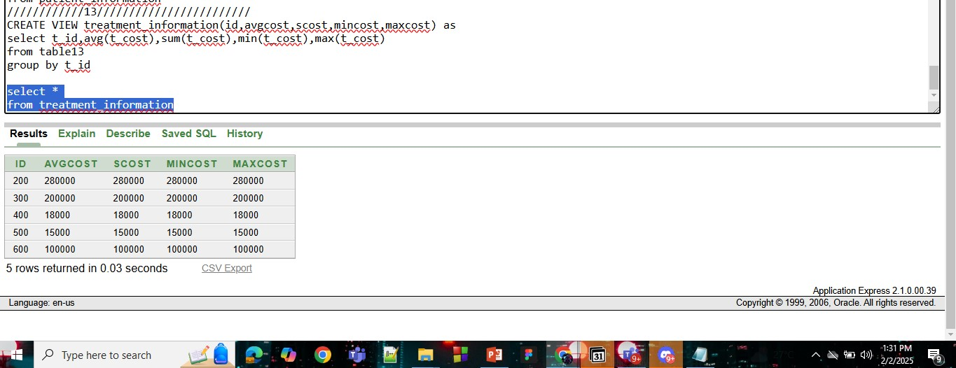

# **Description of a Successful DB connection**

**NAME: ARGHYA DAS**

**ID: 23-54149-3**

**DB Connection :**

1. First I install all the software and jar files.

• Install Xampp Server

• Download mysql-connector-java-9.1.0.jar

1. I open Xampp server from Xampp control panel then start Apache and MySQL module then open phpMyAdmin. There I create a Database by name “ hms (hospital management system) ” and create a table name “ table5 ” then I insert Some values in it.

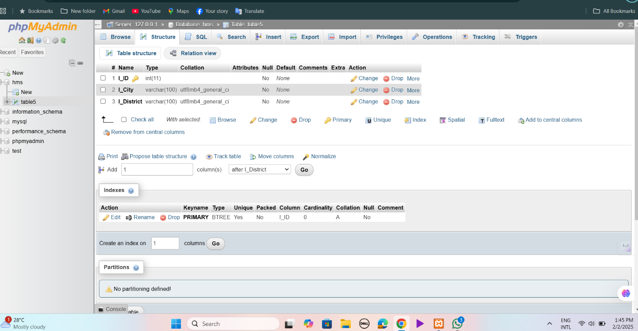

**FIG – 1 :TABLE CREATED AND SHOWING TABLE STRUCTURE**

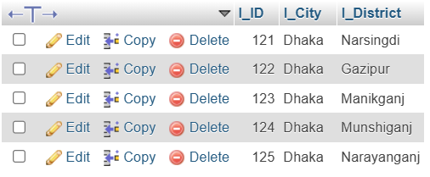

**FIG-2 : INSERT VALUES IN table5**

1. After creating Database and table I created a folder named "Random" on my desktop and placed a simple Java code file inside it. Additionally, I added the MySQL Connector J 9.1.0 (mysql-connector-j-9.1.0.jar) to the same folder.

Next, I opened Notepad++, modified the Java sample code as needed, and saved the updated file within the "Random" folder.

After making these changes, I navigated to the "Random" folder using the Command Prompt and executed the following commands:

**javac -cp Driver.jar;. text.java**

**java -cp Driver.jar;. text**

Upon execution, the program successfully displayed the contents of the table, confirming that the MySQL connection and Java integration worked as expected..

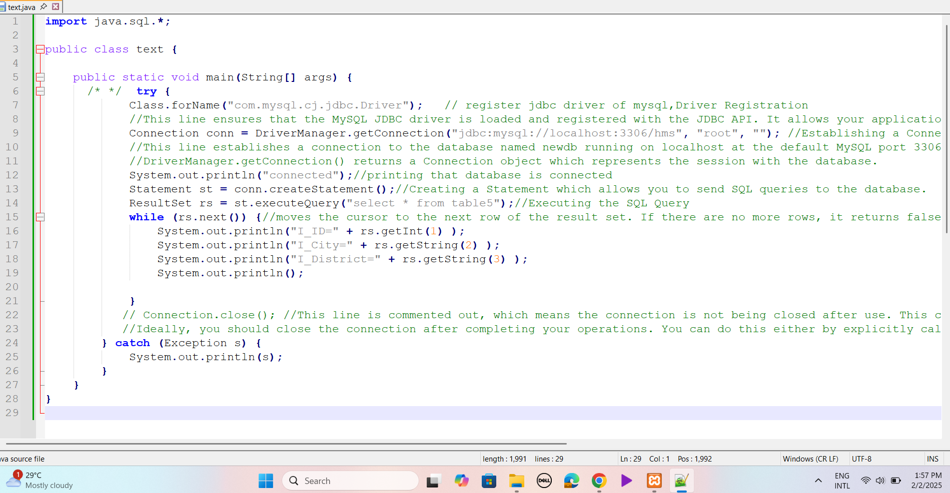

**FIG-3 : DB CONNECTION JAVA CODE**

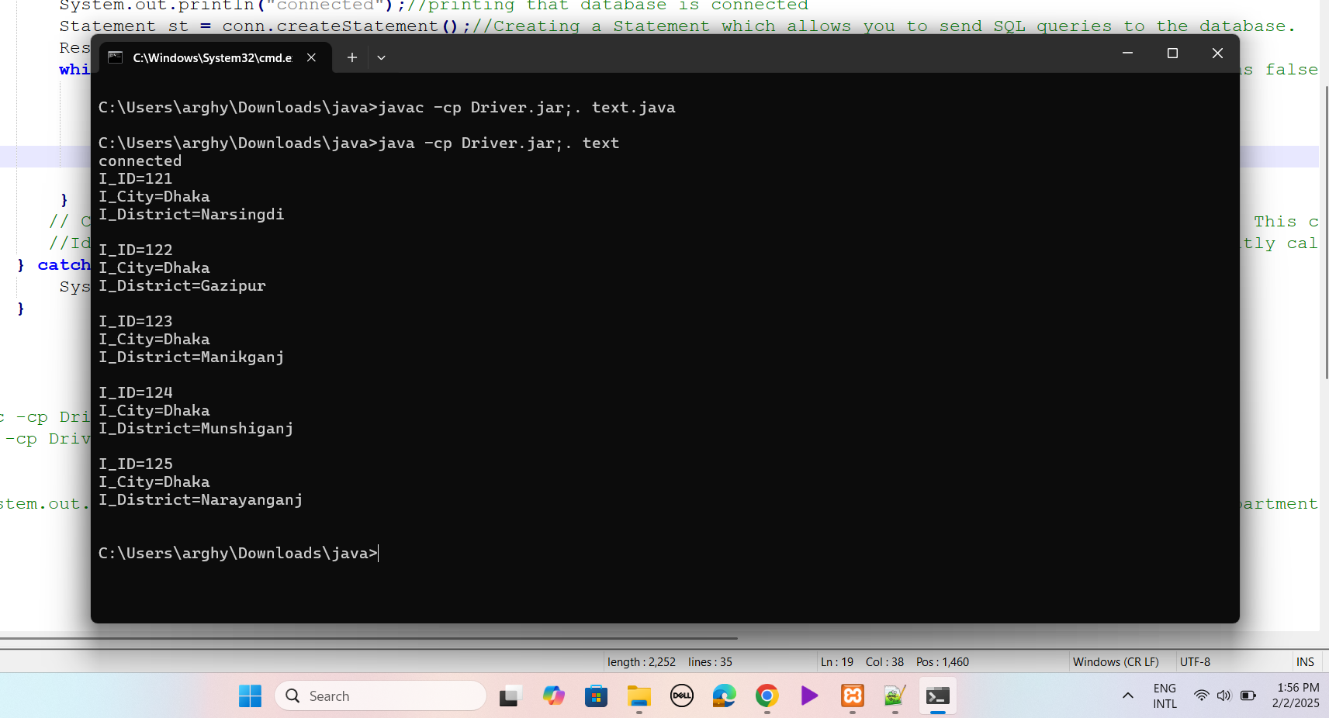

**FIG-4 : OUTPUT**

**Name : Tasfia Maisha Id : 23-54081-3**

**DB Connection :**

1. First I install all the software and jar files.

• Install Xampp Server

• Download mysql-connector-java-9.1.0.jar

I launch the XAMPP server from the XAMPP Control Panel, start the Apache and MySQL modules, and then access phpMyAdmin. Within phpMyAdmin, I create a database named **"hospital_management”** and set up a table called **"table_8"**, into which I insert some values.

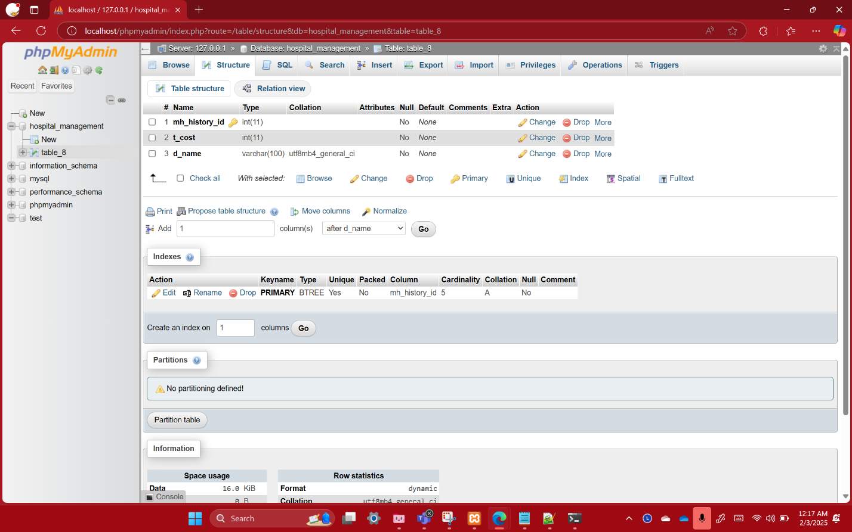

**FIGURE – 1 :TABLE CREATED AND SHOWING TABLE STRUCTURE**

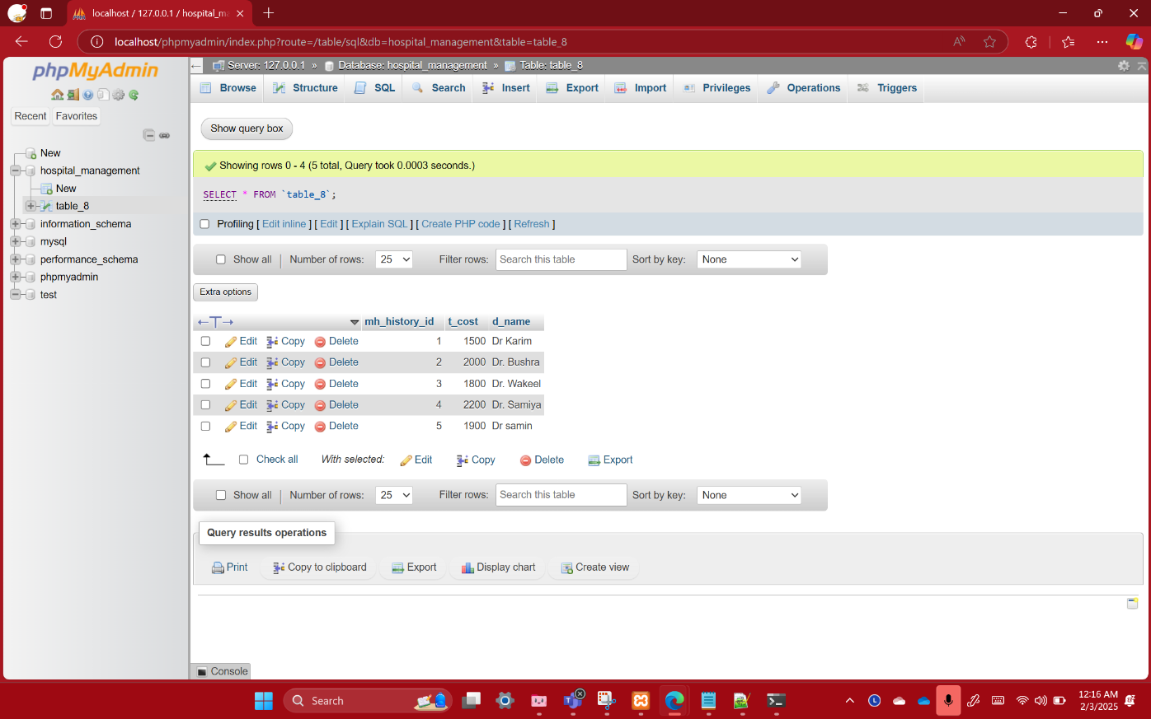

**FIGURE-2 : INSERT VALUES IN table_8**

After setting up the database and table, I created a folder named **"DBS CONNECTION"** on my desktop and placed a simple Java code file inside it. I also included the **MySQL Connector J 9.1.0** (mysql-connector-j-9.1.0.jar) in the same folder.

Then, I opened **Notepad++**, made the necessary modifications to the Java code, and saved the updated file within the **"DBS CONNECTION"** folder.

Once the changes were complete, I accessed the **"DBS CONNECTION"** folder through the **Command Prompt** and executed the required commands.

**javac -cp Driver.jar;. object.java**

**java -cp Driver.jar;. object**

When executed, the program successfully retrieved and displayed the table's contents, verifying that the MySQL connection and Java integration functioned correctly.

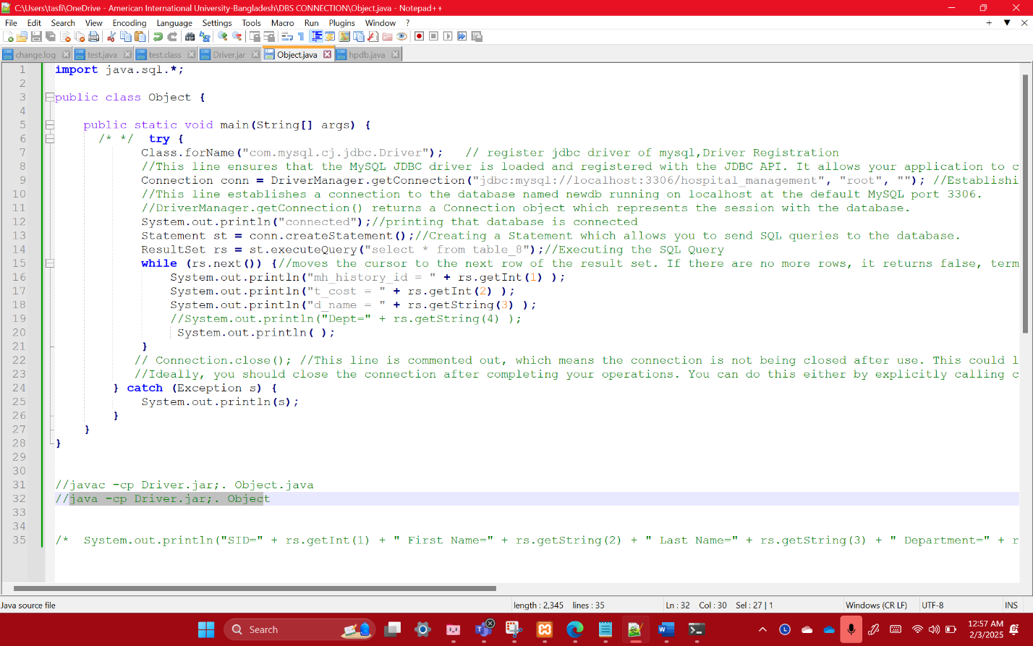

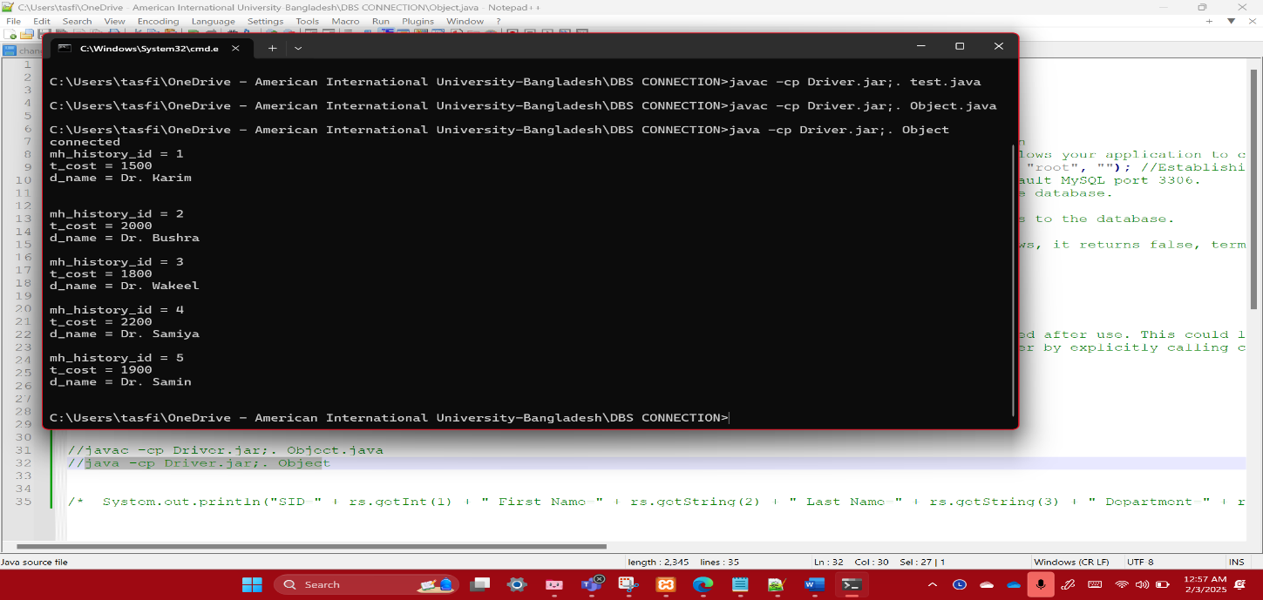**FIGURE-3 : DataBase CONNECTION JAVA CODE**

**FIGURE-4 : OUTPUT**

**NAME: ANIKA AKTER AYNA**

**ID: 23-54139-3**

**DB Connection :**

1. First I install all the software and jar files.

• Install Xampp Server

• Download mysql-connector-java-9.1.0.jar

1. I open Xampp server from Xampp control panel then start Apache and MySQL module then open phpMyAdmin. There I create a Database by name “ hms (hospital management system) ” and create a table name “ table5 ” then I insert Some values in it.

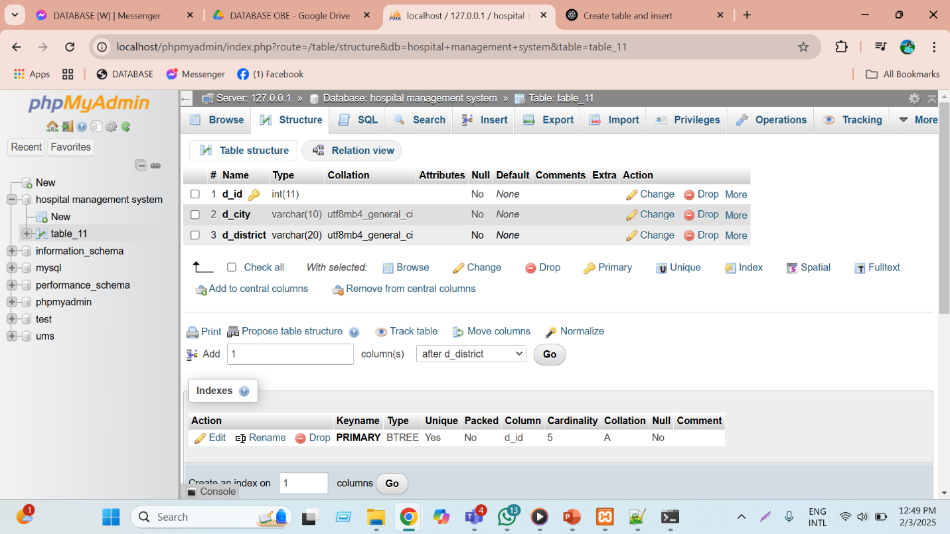

**FIG – 1 :TABLE CREATED AND SHOWING TABLE STRUCTURE**

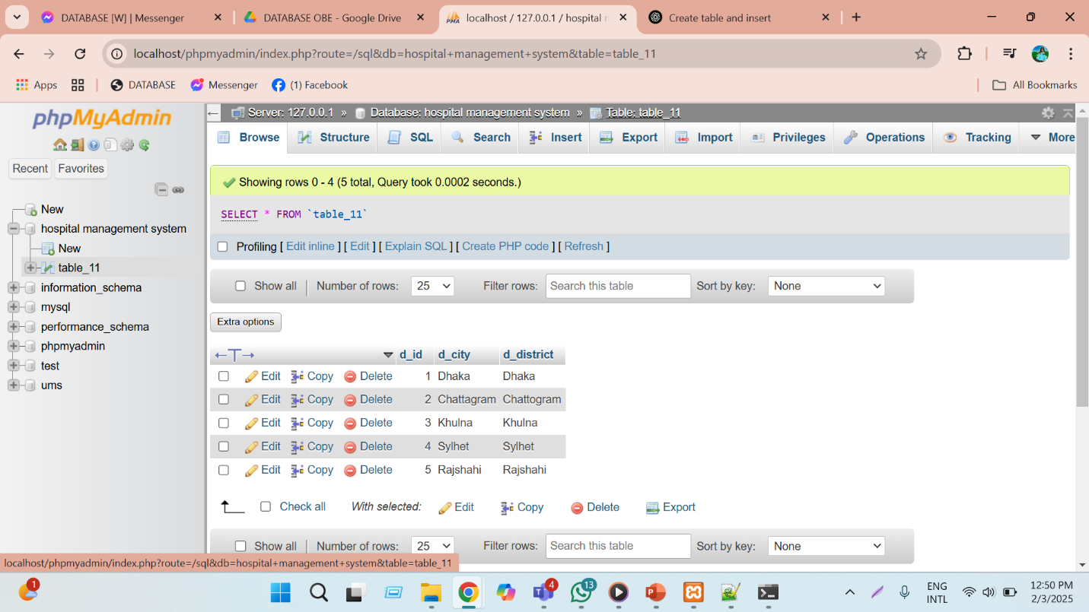

**FIG-2 : INSERT VALUES IN table5**

1. After creating Database and table I created a folder named "Random" on my desktop and placed a simple Java code file inside it. Additionally, I added the MySQL Connector J 9.1.0 (mysql-connector-j-9.1.0.jar) to the same folder.

Next, I opened Notepad++, modified the Java sample code as needed, and saved the updated file within the "Random" folder.

After making these changes, I navigated to the "Random" folder using the Command Prompt and executed the following commands:

**javac -cp Driver.jar;. text.java**

**java -cp Driver.jar;. text**

Upon execution, the program successfully displayed the contents of the table, confirming that the MySQL connection and Java integration worked as expected..

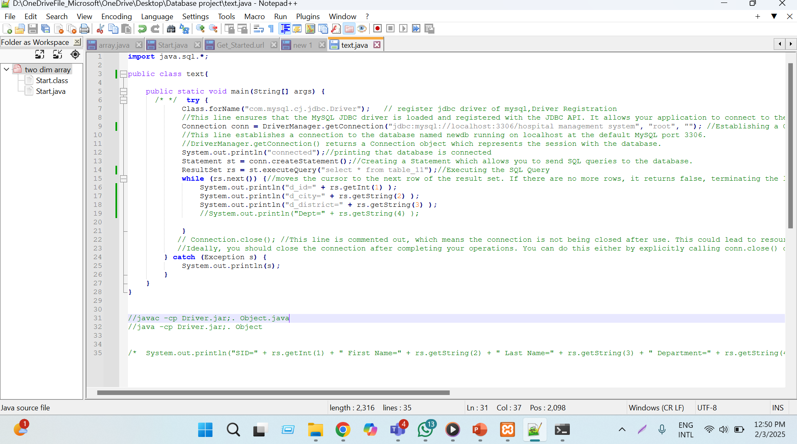

**FIG-3 : DB CONNECTION JAVA CODE**

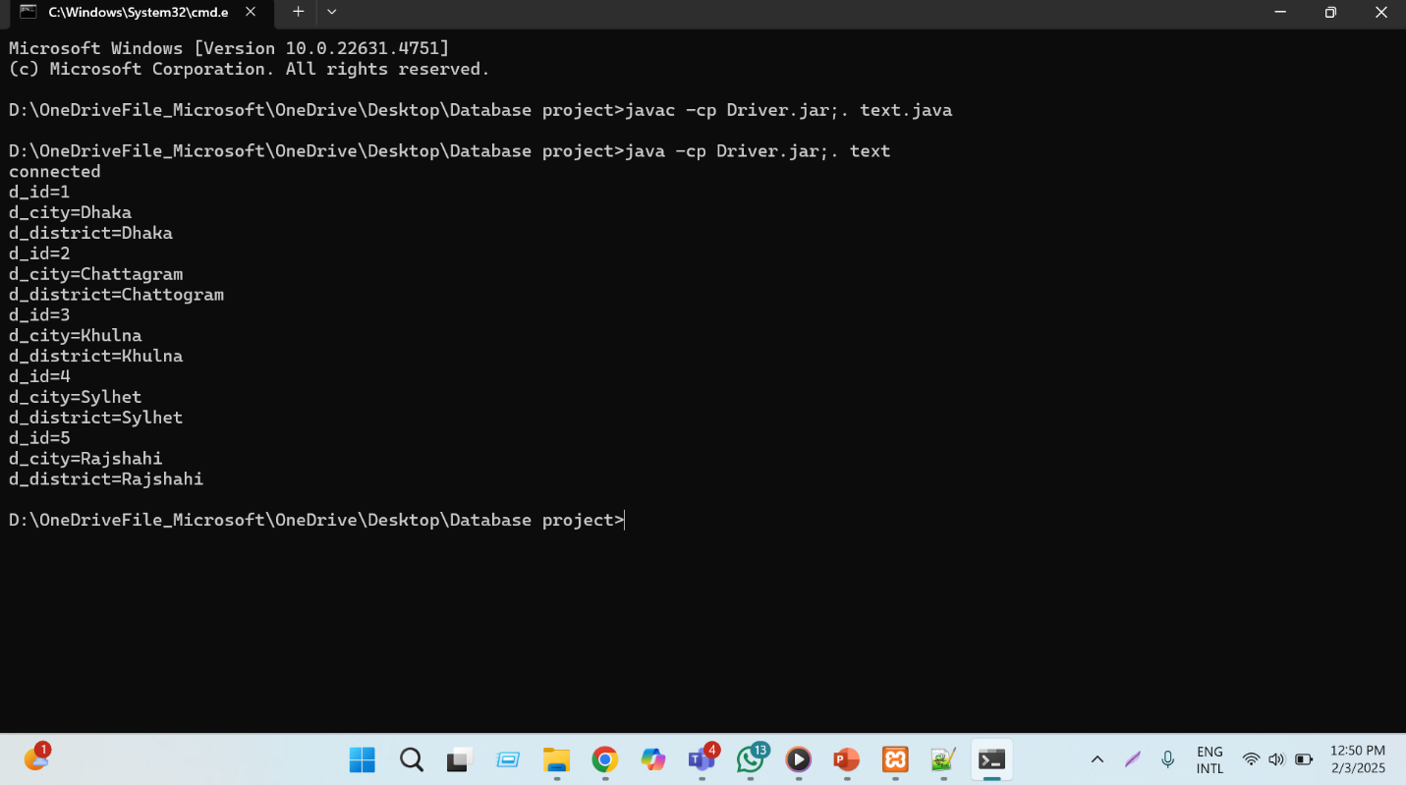

**FIG-4 : OUTPUT**

**NAME: MD.MINHAJUL SHARIAR ZAMAN ALIF**

**ID: 23-54144-3**

**DB Connection :**

1. First I install all the software and jar files.

• Install Xampp Server

• Download mysql-connector-java-9.1.0.jar

1. I open Xampp server from Xampp control panel then start Apache and MySQL module then open phpMyAdmin. There I create a Database by name “ hms (hospital management system) ” and create a table name “ table5 ” then I insert Some values in it.

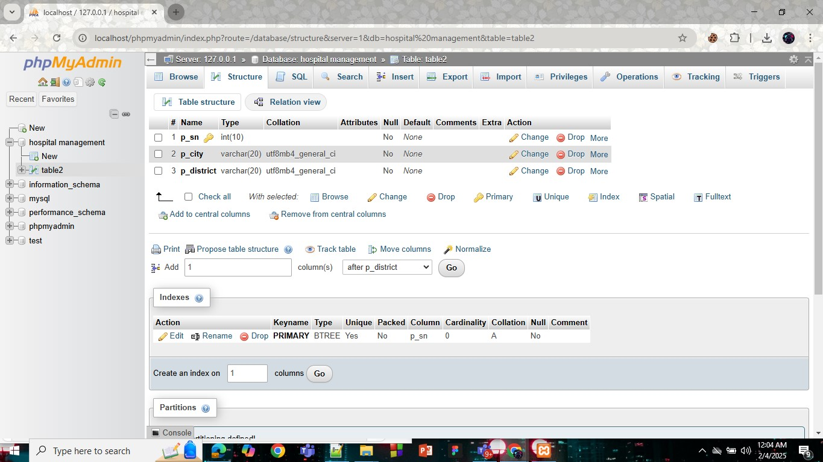

**FIG – 1 :TABLE CREATED AND SHOWING TABLE STRUCTURE**

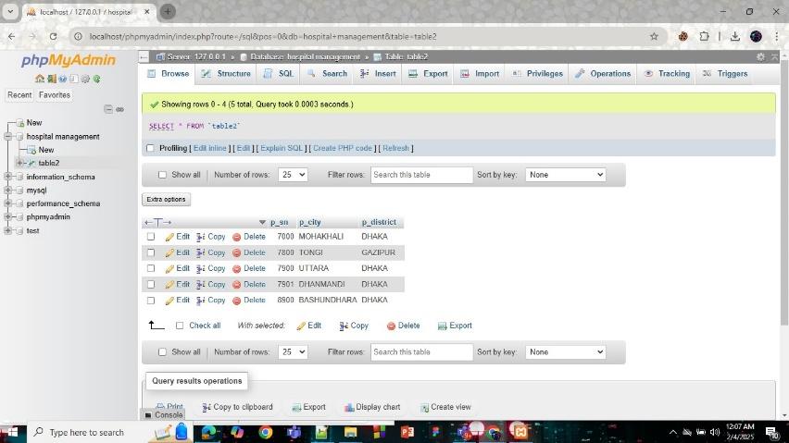

**FIG-2 : INSERT VALUES IN table5**

1. After creating Database and table I created a folder named "Random" on my desktop and placed a simple Java code file inside it. Additionally, I added the MySQL Connector J 9.1.0 (mysql-connector-j-9.1.0.jar) to the same folder.

Next, I opened Notepad++, modified the Java sample code as needed, and saved the updated file within the "Random" folder.

After making these changes, I navigated to the "Random" folder using the Command Prompt and executed the following commands:

**javac -cp Driver.jar;. text.java**

**java -cp Driver.jar;. text**

Upon execution, the program successfully displayed the contents of the table, confirming that the MySQL connection and Java integration worked as expected..

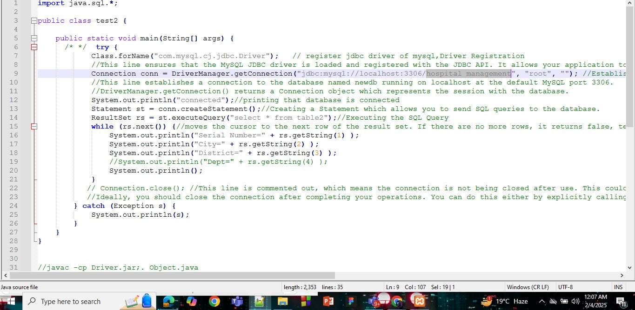

**FIG-3 : DB CONNECTION JAVA CODE**

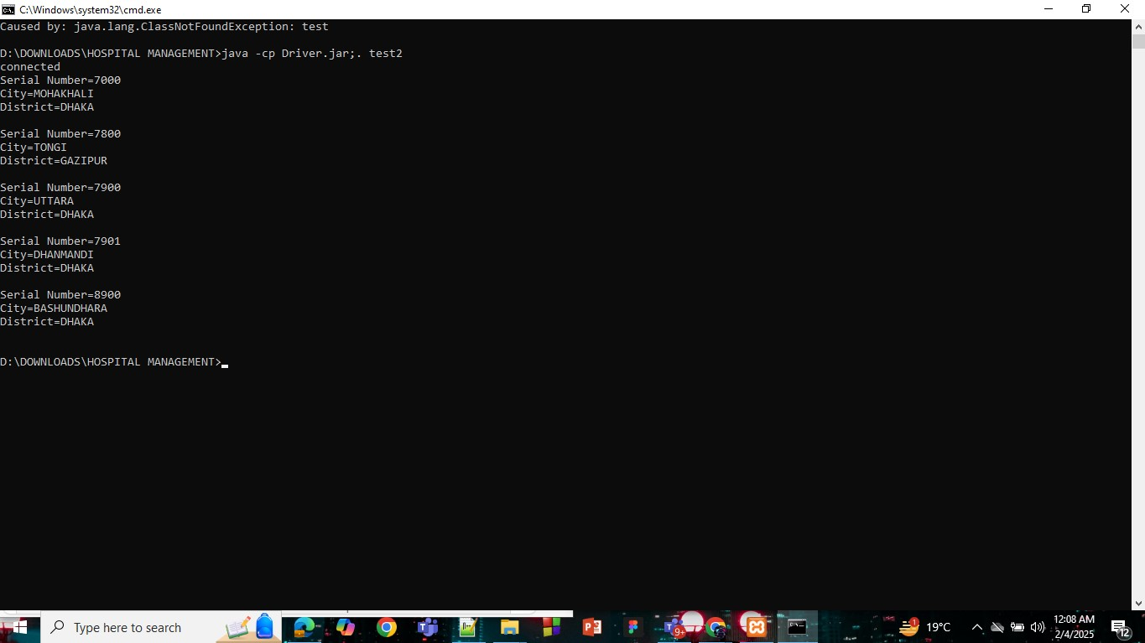

**FIG-4 : OUTPUT**

# **Conclusion**

The Hospital Management System database project provides a cohesive and efficient framework to modernize healthcare administration by integrating critical processes such as patient care, appointment scheduling, treatment tracking, insurance management, and billing. By centralizing patient records through unique identifiers and storing comprehensive details—including demographics, contact information, and dynamically calculated age—the system ensures accurate, accessible, and secure data management. Doctors’ profiles, appointment histories, and treatment procedures are meticulously tracked to foster accountability and continuity of care, while insurance policies and billing transactions are streamlined to enhance transparency. Through normalization techniques like deriving age from date of birth and decomposing complex attributes, the system minimizes redundancy and improves scalability. By automating workflows and strengthening data integrity, this solution empowers healthcare institutions to optimize resource allocation, reduce operational inefficiencies, and prioritize patient-centered outcomes. Ultimately, it stands as a foundational tool for hospitals to deliver reliable, transparent, and high-quality healthcare services.